|  |
| --- |
| **VIETNAM NATIONAL UNIVERSITY HO CHI MINH CITY  THE INTERNATIONAL UNIVERSITY  SCHOOL OF COMPUTER SCIENCE AND ENGINEERING** |



|  |  |
| --- | --- |
|  | |
| **Building an Educational Forum using MEAN-stack technology** | |
| By  LE GIA LE   |  | | --- | |  | |

A thesis submitted to the School of Computer Science and Engineering   
in partial fulfillment of the requirements for the degree of   
Bachelor in Computer Science

Ho Chi Minh City, Vietnam  
Feb, 2018

**ACADEMIC FORUM SYSTEM  
USING MEAN-STACK TECHNOLOGY**

APPROVED BY SUPERVISOR APPROVED BY: COMMITTEE

____________________________ ____________________________

Tran Thanh Tung, Ph.D. Assoc. Prof. Chair Tran Manh Ha,

_______________________________

_______________________________

_______________________________

_______________________________

**Thesis committee**

**TABLE OF CONTENT**

Chapter I Introduction 6

1.1 Problems Statement 6

1.2 Technological problem’s statement 8

1.3 Thesis’ goal 10

Chapter II Background 11

2.1 MEAN components 13

2.1.1 Node.js 13

2.1.2 Express.js 21

2.1.3 Mongo Database 27

2.1.4 Angular.js 45

2.1.5 The components stack up for the project 56

2.2 Related components 57

2.2.1 NPM (Node Package Manager) 57

2.2.2 Bower 60

2.2.3 Passport.js 63

2.2.4 Grunt.js (The JavaScript Task Runner) 67

2.2.5 Nodemon (Auto-Watch-Reload Node.js file) 72

2.2.6 Socket.io 73

2.3 Sum-up Project’s technology background 76

Chapter III System requirements 77

3.1 Usecases by user-stories 77

3.2 Diagrams 84

Chapter IV Methodology 89

4.1 Project overall structure 89

4.2 Diagram, layer 92

4.3 MEAN components 93

4.3.1 The Server-side _ CONTROLER & MODEL 93

4.3.2 Mongo database for MODEL in server 98

4.3.3 Angular.js for VIEW 100

Chapter V Implementation & Result 106

Chapter VI Conclusion 111

6.1 Gains 111

6.2 MEAN stack, the good parts 111

6.3 Overall conclusion 112

Reference 113

**TABLE OF FIGURES**

Figure 1. IU Forum planned content 7

Figure 2 MEAN stack Architecture versus LAMP 9

Figure 3 Intended Project's overall structure 11

Figure 4 Detailed structure of targeted technologies 12

Figure 5 Traditional Blocking I/O HTTP server work flow 14

Figure 6 Node.js http server work flow 14

Figure 7. Event driven characteristic 15

Figure 8 Error-first callback example 17

Figure 9 Asynchrnous function example 18

Figure 10 Event loop inside NodeJS Processing Model 19

Figure 11 Simple explanation of how Event-loop works 19

Figure 12 How to initialize Router 23

Figure 13 Configure view engine by using Express.js 24

Figure 14 generate view 24

Figure 15 Example of Error-handling in Express.js 25

Figure 16 Sum-up Express.js characteristics 26

Figure 17 Types of NoSQL DB 28

Figure 18 Mongoose.js work flow 31

Figure 19 Schema validation example 33

Figure 20 Query builder example 41

Figure 21 Overall view of Angularjs' features 47

Figure 22 AngularJS MVC Architecture 47

Figure 23. Two-way data binding flow 48

Figure 24. Scope integration with event loop 49

Figure 25 Project stacking up using the above components 56

Figure 26 Detailed features of components 57

Figure 27 Example NPM json file 59

Figure 28 Passport.js work flow 65

Figure 29 Passport.js serialize and de-serialize 66

Figure 30 package.json example after installing grunt 70

Figure 31 Initialize socket.io 74

Figure 32 socket.io with express.js 74

Figure 33 Usecase Diagram for theme-1 86

Figure 34 Usecase diagram for theme-2 87

Figure 35 Use-case Hierarchy theme 1 87

Figure 36 Use-case Hierarchy theme 1 88

Figure 37 system entity diagram 88

# Chapter I Introduction

## Problems Statement

Nowadays, many university students experience their university’s life through social networks via news of groups or fan-pages like those on facebook and various storage links like google drive, dropbox, etc. Every school has at least fifty academic- related groups and pages on facebook and it is extremely hard to keep track of the things you need.

Those like Teaching Assistant’s consultant, requesting one-on-one tutor for courses’ test, sample bank of previous semester’s exam questions, hosting a revision session, or maybe just some small and urgent Q& A of desperate students who happen to miss out on one of the courses’ classes, not to mention the social clubs, school social’s activity, contests and events, seminars, scholarship, etc.

All the above are so redundant such that if someone want to keep track of the information that they want, they must open almost ten tabs of web browsers and still barely catch on the needed piece.

More specifically for our International University, if you look on facebook for hash-tags like these below, there would be hundreds of related posts and pages that are concerned constantly by most IU students.

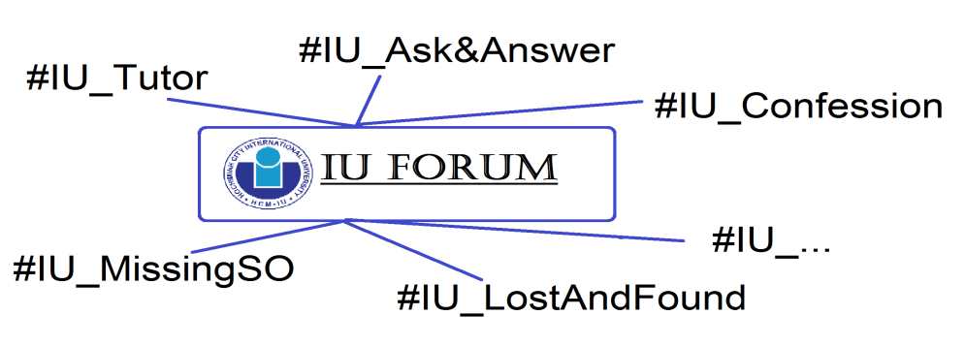

Figure 1. IU Forum planned content

|  |  |
| --- | --- |
| **Current users’  problems** | **Project’s high-light features providing solutions.** |
| Scattered academic resources on various groups, fan-pages of social networks. | ‘Informative Homepage’ and ‘File storage’ 🡺Gather every academic resources then grouped and categorized. |
| Take a lot of time to iterate through all corners to find the needed piece of information. | ‘Real-time responsive Search Tool’ 🡺 extremely fast search engine to minimize the time to locate the desired resource. |
| Ask questions on forums and wait forever to get an answer. | The ‘Chat-bot’ feature for FAQs with high accuracy and immediate respond to users. |
| Very difficult to find a tutor when exams coming and barely set-up or catch-up any tutorial sessions. | The ‘Tutor Finder’ feature together with the ‘Real-time chatting’ feature (public community chat-room and private chat) 🡺easily find a suitable tutor as well as setting up tutorial session that perfectly suit the needs. |

* My aim is to collect and put together student related information into a forum along with some of the most convenient features that would satisfied the needs of a university-life’s experience.

## 1.2 Technological problem’s statement

In the Web-application- development field, MEAN stack is a rising stack which is predicted to overcome former technologies and become the dominant within the next few years. It has proven with strong components that bring the very useful features for a web application.

|  |  |
| --- | --- |
| **The old software stacks’  setbacks** | **The new MEAN stack’s  solutions** |
| Already fast development | * Even faster development process |
| Heavy-size code pack and libraries. | * Light-weight code pack and libraries |
| Hard conversion to exchange communication with other technologies. | * JSON everywhere ==> very easy to communicate and interact with other parties or systems. |
| Loosely connected components | * Firmly connected, every component is json-based (native data language of JavaScript) and created for stacking up with others. |
| Slow page-loading technique. | * Very fast loading because of the Angular’s single page application concept. |
| Relational databases support for highly complex structured queries 🡪 well to calculate complicated data.  🡪 **not very fit** for forum-style applications. | * Non-relational databases excel at managing operational data, such as a list of objects in a system. * Perfectly fit for forum-style apps. |
| Multiples style of coding and language dependency. | * Single code base, one language for the whole system |
| Traditional multi-threaded Apache setups are resource-heavy and complicated to configure. | * Node has a web server built in.   🡺The same process is applied for every request going through , without having to consider the file-system to see which process of script to run. |

**The MEAN stack** represents a thoroughly modern approach to web development: one in which a single language (JavaScript) runs on every layers of your application, from client to server. It also has strong support for fast-speed single-page web application.

One of the earliest collections of open source web technologies to gain prominence is the LAMP stack. These technologies weren't written to work together. They are discrete projects that some programmers trying to get them cobbled together.

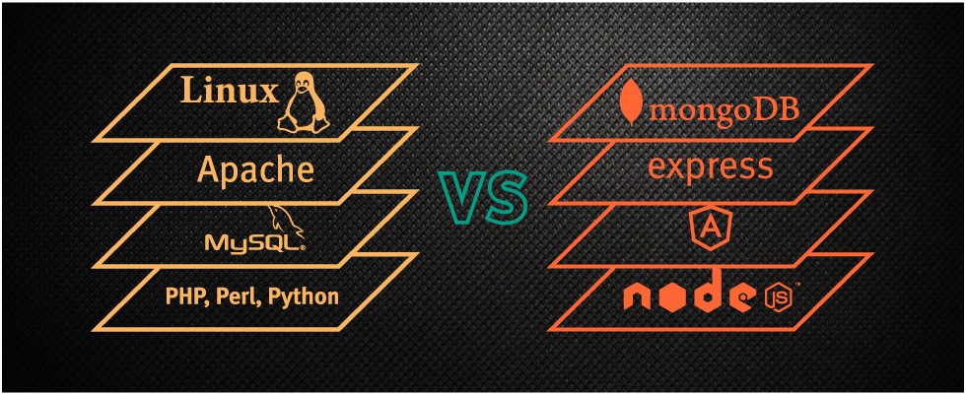

Figure 2 MEAN stack Architecture versus LAMP

MEAN is more than a simple re-arrangement of acronym letters and technology upgrades. Switching the base platform from an OS (Linux) to a JavaScript runtime (Node.js) brings OS independence: Node.js runs as well on Windows and OS X as it does on Linux.

Node.js also replaces Apache in the LAMP stack. But Node.js is far more than a simple web server. Truth be told, you don't send your completed application to a remain solitary web server, rather, the web server is incorporated into your application and introduced auto-mysteriously in the MEAN stack. The arrangement procedure is drastically less complex subsequently, in light of the fact that the required rendition of the web server is unequivocally characterized alongside whatever remains of your run-time conditions.

Regardless, the best differentiation from LAMP to MEAN is the move from traditional server-side page age to a client side single-page application (SPA) orientation.

With Express, you can in any case handle server-side directing and page age, yet the accentuation is presently on customer side perspectives, affability of AngularJS. This change includes more than basically moving your?Model-View-Controller (MVC) artifacts from the server to the client.

## 1.3 Thesis’ goal

In this thesis’ project, I want to use the MEAN stack to build the academic forum along with these high-light features that definitely provide solutions to the existing problems.

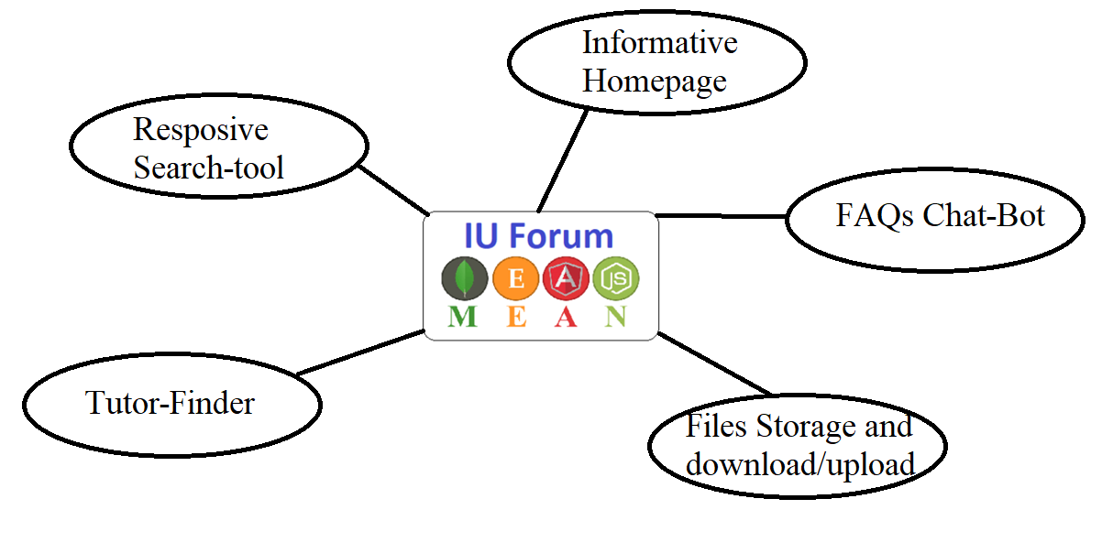

This forum project is a put-to-the-test for confirmation over the stack’s hype.

# Chapter II Background

This is the intended structure of my project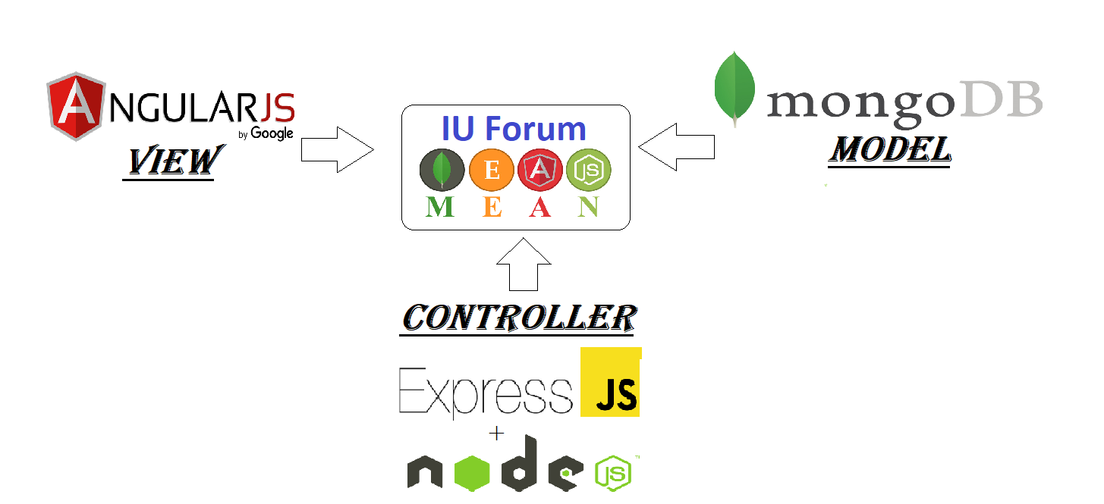

Figure 3 Intended Project's overall structure

To be more detailed,

These specific features of the targeted technological components will be used:

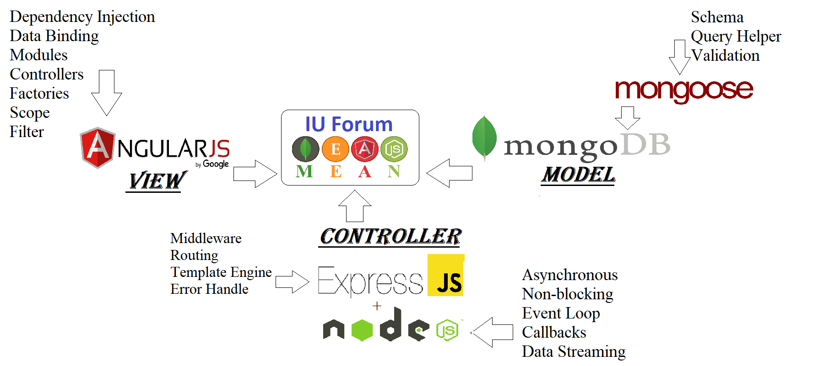

Figure 4 Detailed structure of targeted technologies

And we will go through all the theoretical of every single components in the next parts to explain what are the good parts of that particular component.

## 

## 2.1 MEAN components

### 2.1.1 Node.js



#### 2.1.1.1Node.js’ Definition

Node.js is a powerful JavaScript-based cross-platform runtime and library environment built on Google Chrome's JavaScript V8 Engine for running JavaScript applications outside the browser. It is used for creating server-side and networking web applications.

Node.js’ event-driven, non-blocking I/O model makes it exceptionally lightweight, to a great degree proficient and reasonable for information serious.

It also provides various library of JavaScript modules which cut down the complexity of web development & Node.js applications considerably.

In short words,

Node.js = Runtime Environment + JavaScript Library 🡺 Server-side Javascript

#### 2.1.1.2 Understand how node.js works

* The principle thought of Node.js:

Hub utilizes non-blocking, occasion driven I/O to remain light-weighted and compelling.

While customary web-serving strategies where every association (ask for) brings forth another string, taking up framework RAM and in the long run maximizing at the measure of RAM accessible [8]



Figure 5 Traditional Blocking I/O HTTP server work flow

Node.js works on a solitary string, utilizing non-blocking I/O calls, enabling it to help a huge number of concurrent associations which will be held in the Event-loop.



Figure 6 Node.js http server work flow

Instead of spawning a new OS thread for each connection (and allocating the accompanying memory with it), each connection fires an event run within the Node engine's process.

##### **Event-driven**



Figure 7. Event driven characteristic

Occasion driven writing computer programs is a programming original in which the stream of that program is chosen by occasions like client connections, or activating messages from different projects/strings. [19]

In an event-driven application, there is typically:

A fundamental circle breaking down occasions   
🡪triggers a callback capacities

🡪 relating occasions.

##### **Non-blocking I/O**

A non-blocking deployment does NOT wait for I/O to be completely done. [19]

While blocking task constrained the procedure to be set aside for later at the working framework level, playing out a non-blocking I/O activity

A non-blocking call triggering start the operation, leaves it for the operating system to complete returning instantly without any results.

Alternatively equivalents methods are then used to decide completion of the I/O operation.

A non-blocking call makes results to be returned asynchronously.

##### **Asynchronous**

When you execute a task synchronously, you wait for that task to finish before carrying on to another task. However when you execute it asynchronously, you do not wait, you can just move on to another task before the current task complete.[19]

Asynchronous I/O is a model of info/yield taking care of that enables other preparing to proceed before the present transmission has wrapped up.

Each capacity in Node.js is offbeat. Along these lines, everything that would commonly block the string is executed out of sight. This is the most pivotal thing to recall about all modules of Node.js. For instance, on the off chance that you are perusing a document utilizing the modulde ?record framework?, you need to determine a callback work that is executed when the read activity has finished.

The server can respond to multiple requests simultaneously. It will not hold or block any API request and will respond to all when the response is ready to send accordingly.

##### **Callback**

Callback is a function which is called at the completion of each task. In Node.js, callbacks are used almost every corners. All APIs of Node supports callbacks.

For instance: when a capacity begin perusing document, it restores the control to execution condition quickly with the goal that the following direction can be executed.

How callbacks were made: when you pass a capacity on to another capacity as a parameter, you can call it inside the capacity when you complete your activity. No requirement for return esteems, just calling another capacity with the qualities.

These blunder first callbacks are in the center of Node.js Almost every modules are utilizing it.



Figure 8 Error-first callback example

*Things to notice:

Error-handling:

Instead of a try-catch block you have to check for errors in the callback -no return value:

Asynchronous functions don't return values, but values will be passed to the callbacks



Figure 9 Asynchrnous function example

Once started to read our file the execution continued, and printed ‘end of the file’. the callback was only called once the file read was finished.

How is it possible? 🡪 let’s move on to the part of **Event loop**.

##### **Event loop**

The event loop support Node.js to execute non-blocking I/O operations despite the fact that JavaScript is single-threaded, by unpacking operations to the system center whenever possible. [19]

The event loop is in the most crucial of Node.js - it is responsible for scheduling asynchronous operations.



Figure 10 Event loop inside NodeJS Processing Model



Figure 11 Simple explanation of how Event-loop works

It simply goes over and over again the event queue which is basically a stack of events and callbacks of completed operations.

All I/O is carried out asynchronously by the threads in the thread pool. If an item asks for an I/O, the event loop simple consigns the operation to the thread pool. Event loop then continues executing other items in the event queue. Once the I/O operation is complete, the callback is queued for processing. [19]

Event loop deploys the callback and provide appropriate results. Since, it’s in a loop, the process simply keeps going on and on.

#### 2.1.1.3 So why we use Node.js for the server-side

Above all else, utilizing Node.js as your server innovation gives you an extraordinary lift that originates from utilizing a similar dialect on both the front end and the back end.

This, implies your group is more productive and cross-practical, which, thus, prompts bring down advancement costs.

Notwithstanding that, it worth specifying that JavaScript is the most prominent programming dialect, so your application’s codebase will be less demanding to comprehend for more designers.

You can likewise reuse and share the code between the front-end and the back-end parts of your application, which accelerates the advancement procedure.

Over that, the Node.js people group is always developing ? the quantity of group questions is relentlessly expanding, so the learning base for the innovation is generally accessible.

At last, Node offers an incredible bundle manager, npm, and the measure of accessible open-source devices in npm’s registry is monstrous and developing quick. These are only a couple of numerous favorable circumstances of Node.js that you ought to consider while picking the innovation for your project.

* It is fast
* Expedites the Development Process
* Excellent for Real-Time App Development
* Data streaming in Node.js : Stream everything, never force the buffering of data . So it is preferred for video uploading. Node.js cuts down the overall processing time while uploading audio and video files.
* Benefit the developers when they are working on real-time audio or video encoding
* Effective single code-base JavaScript exists in both the browser and the server.

One language for the whole system.

### 2.1.2 Express.js



Let’s jump to the next crucial component in the MEAN stack,

**The Express.js framework**.

#### 2.1.2.1So what is Express.js ?

Express 3.x is a light-weight **modular web application framework** to help organize web application into MVC architecture on the server side.[9]

It allow you structure a web application to handle multiple different http requests at a specific url which makes developing websites, web apps, & API’s much easier.

The principle characteristics of Express.js are simplicity, minimalism, flexibility, scalability and it also inherit node’s fast performance.

#### In short, what Express.js is to Node.js is pretty much like what Bootstrap is to HTML/CSS and responsive web design.

ExpressJS is pass on the most popular NodeJS structure to such an extent that when the vast majority discuss NodeJS they clearly mean NodeJS+ExpressJS.

Express.js is used in creating server side web applications faster and smarter, easy to configure and customize, allows you to create rest API server, easy to connect with databases. [9]

Because Node.js itself wasn’t planned to assemble sites, the Express system can layer in worked in structure and capacities expected to really manufacture a site. It?s an entirely light-weight system that?s extraordinary for giving additional, worked in web application highlights and the Express API without superseding the effectively hearty, include pressed Node.js stage.

To put it plainly, Express and Node are changing the way designers assemble sites, and they could barely be isolated from each other.

#### 2.1.2.2 Understand how Express.js works

##### **Middleware [mid layer]:**

Each piece of middleware is just another request handler. You start by looking at the first request handler, then you look at the next one, then the next, and so on.

With middleware functions, you can make your own customization on any incoming request and modify it before returning a response.

start with app.use().

This method tells the app to use the parameters you're giving it. This can be a function or a path and a function.

This means that these are simply rules that need to be applied for the routes coming up next.

##### **Routing [top layer]:**

Routing is a way to map different requests to specific handlers.

To make use of Express' routing capabilities you need to initiate a new Express Router.

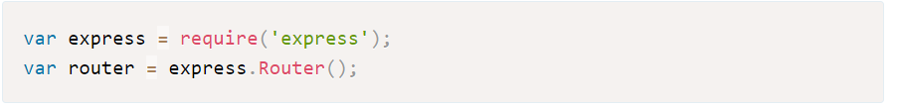

Figure 12 How to initialize Router

When you have the router object you can use its five routing methods. [19]

.get() when you visit a site you make a GET ask. You can get information from a URL in a GET ask for as well.

.put() is a technique used to refresh information. At whatever point I need to refresh information in one of my applications, I utilize a PUT ask.

.post() is a technique utilized wherever for posting data to a server/application. You'll need to utilize this for submitting frames.

.delete() is entirely obvious. Utilize this technique to erase information.

.all() is the strategy which goes about as any of the above.

On the off chance that you include the .all() strategy to a course, and go in the next() parameter, you can run a capacity for each demand. On the off chance that you include the .all() method best of your different courses that need validation it could spare you a considerable measure of time and exertion.

Let take a look at how Express.js execute common routines (routing)

Routes allow us to script specific actions based on the path.

The options include GET, POST, PUT and DELETE.

Presently you can follow the full way from demand to reaction.

In any case, as your application develops in measure, you won't have any desire to code the tenets for each course exclusively. You will locate that a few courses share similar tenets, so you have to figure out how to apply one arrangement of guidelines to various courses.

The switch gives you a chance to aggregate your courses with the goal that you can make normal principles.

##### **Template engine**

Here's what the setup looks like when Express handle views.

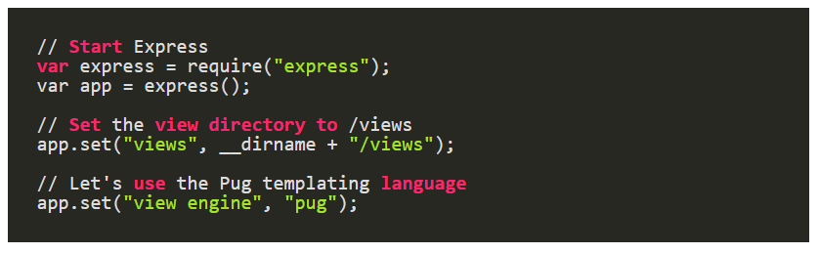

Figure 13 Configure view engine by using Express.js

We need to render the view from within Express: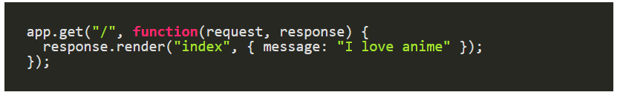

Figure 14 generate view

It basically looks at the view engine and views directory (the stuff we defined earlier) and renders index.pug.

##### **Error handling**

* When you're building up an Express application, you will commit a couple of errors. Much the same as in some other programming dialect/structure. However a few blunders are extremely valuable to you since you're an engineer yet may likewise be helpful to somebody with terrible expectations. That is the reason we would prefer not to print a "stack follow" mistake when we're underway.

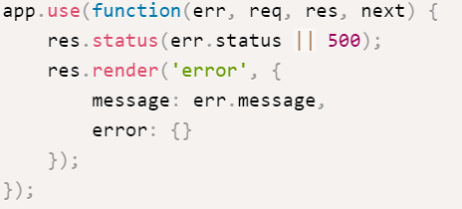

Figure 15 Example of Error-handling in Express.js

You can consider Express a tool belt for making web applications with Node.js. It gives capacities to basically all that you have to do to fabricate a web server. If you somehow happened to compose a similar usefulness with vanilla Node.js, you would need to compose altogether more code.

#### 2.1.2.3 Why use Express.js?

Express helps you respond to requests with route support so that you may write responses to specific URLs

Express is preferred because it adds dead simple routing and support for Connect middleware, allowing many extensions and useful features.

* sessions
* POST body / query string parsing
* easy templating (jade, mustache, ejs, etc)
* graceful error handling that won't cause the entire server to crash

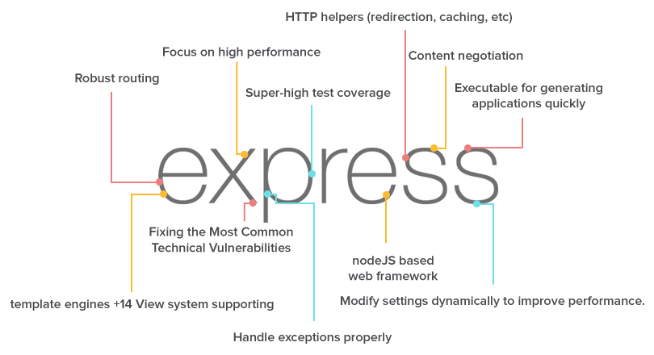

Figure 16 Sum-up Express.js characteristics

Fundamentally, what Express does is that it empowers you to effectively make web applications by giving a marginally less complex interface to making your demand endpoints, taking care of treats, and so forth than vanilla Node. You could drop it out of the condition, however then you'd need to complete significantly more work in throwing together your web-application. Hub itself could do everything express is doing (express is actualized with hub), however express just wraps it up in a more pleasant bundle. [19]

The reason it is acclaimed because?Easy expectation to absorb information. There are parcel of inbuilt, outsider middleware good with it. It general gives finish structure in clean syntax.It is only an arrangement of prepared capacities and modules that can be utilized less demanding than composing code from zero.

🡺It saves time.

There is also a lot of resources on nodejs with express.

### 2.1.3 Mongo Database



#### 2.1.3.1 Definition of NoSQL

NoSQL is a way to deal with database outline that can accomodate a wide assortment of information models, including key-esteem, report, columnar and chart designs. NoSQL, which remain for "not just SQL," is an other option to customary social databases in which information is put in tables and information construction is painstakingly planned before the database is manufactured. NoSQL databases are particularly helpful for working with substantial arrangements of appropriated information. [10]

A NoSQL database is precisely the kind of database that can deal with the kind of unstructured, muddled and flighty data that our arrangement of engagement requires.

The least demanding approach to consider NoSQL, is that of a database which does not sticking to the conventional social database administration MongoDB is an open-source database that uses a record situated information demonstrate. MongoDB is one of a few database writes to emerge in the mid-2000s under the NoSQL standard. Rather than utilizing tables and lines as in social databases, MongoDB is based on a design of accumulations and reports. Reports contain sets of key-esteem combines and are the essential unit of information in MongoDB. Accumulations contain sets of reports and capacity as what might as well be called social database tables.

It is not built on tables and does not employ SQL to manipulate data. It also may not provide full ACID (atomicity, consistency, isolation, durability) guarantees, but still has a distributed and fault tolerant architecture.

*[22] Common Types of NoSQL Databases:

* Key-value model—the minimum complex NoSQL choice, which stores information in a pattern less manner that comprises of filed keys and values.?Examples: Cassandra, Azure, LevelDB, and Riak.
* Column store—or, wide-column store, which stores information tables as segments as opposed to columns. It?s something beyond a transformed table?sectioning out sections takes into consideration superb versatility and high performance.?Examples: HBase, BigTable, HyperTable.
* Document database—taking the key-esteem idea and including greater unpredictability, each record in this kind of database has its own particular information, and its own particular novel key, which is utilized to recover it. It?s an extraordinary choice for putting away, recovering and overseeing information that?s record arranged yet at the same time to some degree structured.?Examples: MongoDB, CouchDB.
* Graph database—have data that’s interconnected and best represented as a graph? This method is capable of lots of complexity. Examples: Polyglot, Neo4J.

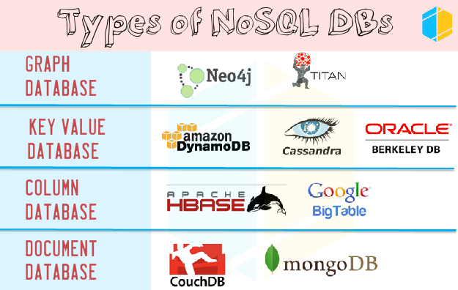

Figure 17 Types of NoSQL DB

#### 2.1.3.2 Definition of Mongo Database

MongoDB is an open-source database that uses a document-oriented data model. MongoDB is a blueprint less NoSQL report database. It implies you can store JSON records in it, and the structure of these archives can differ as it isn't upheld like SQL databases. This is one of the upsides of utilizing NoSQL as it accelerates application improvement and decreases the multifaceted nature of organizations. [10]

MongoDB is a **schema-less NoSQL document database**. It implies you can store JSON reports in it, and the structure of these records can shift as it isn't implemented like SQL databases. This is one of the benefits of utilizing NoSQL as it accelerates application advancement and decreases the many-sided quality of arrangements.

MongoDB stores information in adaptable, JSON-like records, which means fields can fluctuate from archive to report and information structure can be changed after some time .

The document model maps to the objects in your application code, making data easy to work with

\***Terminologies**: [11]

* Collections: in Mongo are equivalent to tables in relational databases. They can hold multiple JSON documents.
* Documents: are equivalent to records or rows of data in SQL. While a SQL row can reference data in other tables, Mongo documents usually combine that in a document.
* Fields: or attributes are similar to columns in a SQL table.
* Schema: While Mongo is blueprint less, SQL characterizes a pattern by means of the table definition. A Mongoose ?diagram? is an archive information structure (or state of the record) that is authorized by means of the application layer..
* Models: are higher-arrange constructors that take a pattern and make an occurrence of a report comparable to records in a social database.

#### 2.1.3.3 Understand how MongoDB works

##### **Mongoose**



Mongoose is an Object Document Mapper (ODM). This implies Mongoose enables you to characterize objects with a specifically construction that is mapped to a MongoDB record. It oversees connections between information, gives outline approval, and is utilized to interpret between objects in code and the portrayal of those items in MongoDB. [18]

MongoDB is open-source, non-social database created.

MongoDB stores data as documents in a binary representation called BSON (Binary JSON).

Related data is put away together for quick question access through the MongoDB inquiry dialect.

Fields can shift from archive to record; there is no compelling reason to proclaim the structure of reports to the framework ? records are self-depicting. In the event that another field should be added to a report, at that point the field can be made without influencing every single other record in the accumulation, without refreshing a focal framework inventory, and without taking the framework disconnected. [18]

Optionally, schema validation can be used to enforce data governance controls over each collection.

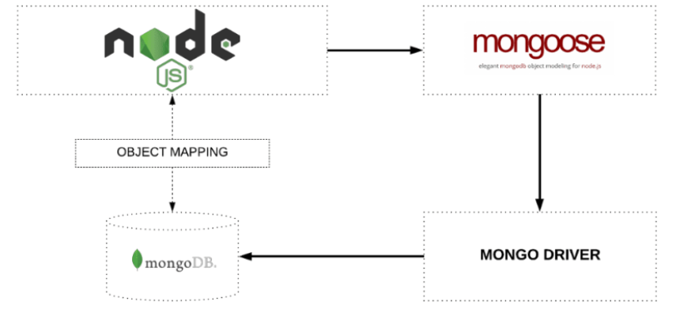

Figure 18 Mongoose.js work flow

##### [**Defining your schema**](http://mongoosejs.com/docs/guide.html#definition)

Everything in Mongoose begins with a Schema. Every pattern maps to a MongoDB accumulation and characterizes the state of the archives inside that gathering.

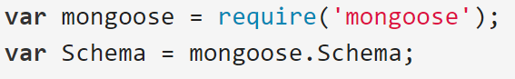

Each key defines a property in records which will be thrown to its associated SchemaType.

SchemaTypes handle meaning of way defaults, approval, getters, setters, field choice defaults for questions and other general attributes for Strings andNumbers. Look at their separate API documentation for more detail.

The permitted SchemaTypes are:

String, Number, Date, Buffer, Boolean, Mixed, ObjectId, Array.[20]

##### **Creating a model**

Models are indulgent constructors requested from our Schema definitions. Events of these models address documents which can be saved and recouped from our database. All record creation and recuperation from the database is dealt with by these models.

We need to call the model constructor on the Mongoose case and pass it the name of the amassing and a reference to the example definition.

Models are created from schemas using the mongoose.model() method:

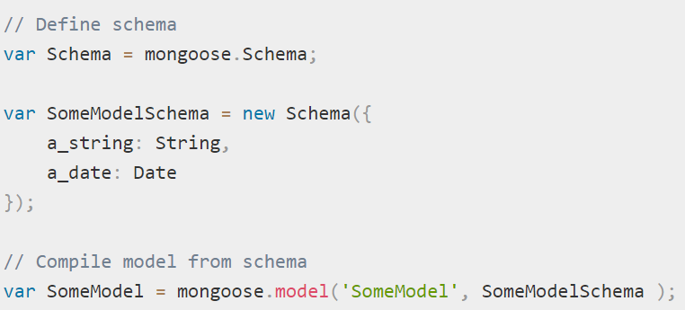

The principle conflict is the single name of the social event that will be made for your model (Mongoose will make the database gathering for the model ), and the second dispute is the mapping you have to use in making the model.

##### **Validation**

Before we get into the specifics of approval sentence structure, alongside the accompanying standards:

* Approval is characterized in the SchemaType
* Approval ismiddleware. Mongoose registers approval as a pre('save')?hook on each diagram naturally.
* You can physically run approval using doc.validate(callback) or doc.validateSync()
* Validators are not keep running on unclear esteems. The main special case is the required validator.
* Approval is nonconcurrently recursive; when you call Model.save, sub-record approval is executed also. On the off chance that a mistake happens, your Model#save? callback gets it
* Approval is adaptable .

Mongoose also has several built-in validators.

All SchemaTypes have the assembled in required validator. The required validator utilizes the SchemaType gheckRequired() function to decide whether the esteem fulfills the required validator.

Numbers have min and max validators. (Built-in validatiors)

Strings—have, enum, match, maxlength and minlength validators.

Each of the validator connects above give more data about how to empower them and modify their blunder messages. 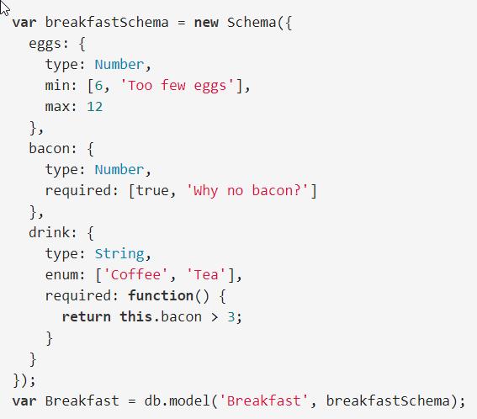

Figure 19 Schema validation example

##### **Query Helpers ( for Basic Operations )**

Mongoose has an adaptable API and gives numerous approaches to achieve an undertaking. We won't center around the varieties since that is out of degree for this article, yet recall that the greater part of the activities should be possible in excess of one way either grammatically or through the application design.

Anyplace a callback is passed to an inquiry in Mongoose, the callback takes after the example callback(error, comes about). What comes about is relies upon the activity: For findOne() it is a conceivably invalid single record, discover() a rundown of archives, check() the quantity of reports, refresh() the quantity of archives influenced, and so forth. The API docs for Models give more detail on what is passed to the callbacks.

* **Insert [CREATE]**

Model.prototype.save()

Saves this document.

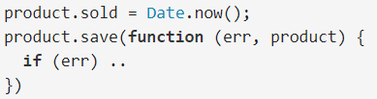

The callback will receive three parameters

err if an error occurred

product which is the saved product

As an extra measure of flow control, save will return a Promise.

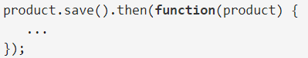

Model.create()

Shortcut for saving one or more documents to the database. MyModel.create(docs) does new MyModel(doc).save() for every doc in docs.

This function triggers the following middleware: save()

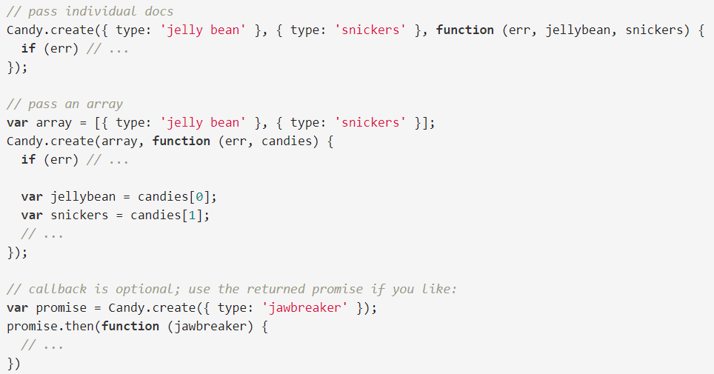

Model.insertMany()

Shortcut for validating an array of documents and inserting them into MongoDB if they're all valid. This function is faster than .create() because it only sends one operation to the server, rather than one for each document. [18]

Mongoose always validates each document before sending insertMany to MongoDB. So if one document has a validation error, no documents will be saved, unless you set the ordered option to false.

This function does not trigger save middleware but it triggers the following middleware.

* **Querying [**READ]

Archives can be retreived utilizing every model discover, findById, findOne, or where static techniques.

Any model technique which includes determining question conditions can be executed two ways:

At the point when a callback work:

* is passed, the task will be executed quickly with the outcomes go to the callback.
* isn't passed, an occasion of Query is returned, which gives a unique inquiry developer interface.

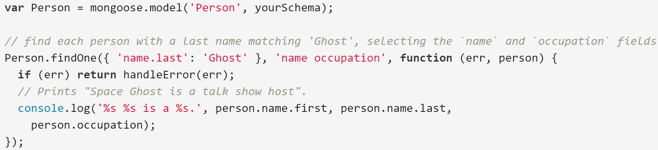

Model.find() finds documents

The conditions are cast to their respective SchemaTypes before the command is sent.

Model.findById()

Finds a single document by its _id field. findById(id) is almost* equivalent to findOne({ _id: id }). If you want to query by a document's _id, use findById() instead of findOne().

The id is cast based on the Schema before sending the command.

Model.findOne()

Finds one document.

The conditions are cast to their respective SchemaTypes before the command is sent.

Note: conditions is optional, and if conditions is null or undefined, mongoose will send an empty findOne command to MongoDB, which will return an arbitrary document. If you're querying by _id, use findById()instead.

* **Updating [UPDATE]**

findAndModify()

Each model has its own update method for modifying documents in the database without returning them to your application.

You can also use .set() to modify documents.

Model.update()

Updates one document in the database without returning it.

This function triggers the following middleware.

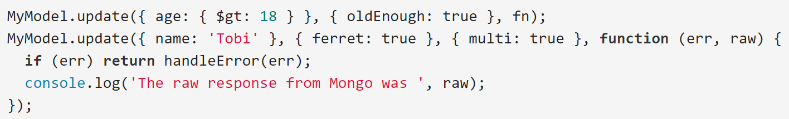

Model.updateMany()

Same as update(), except MongoDB will update all documents that match criteria (as opposed to just the first one) regardless of the value of the multi option.

Note updateMany will not fire update middleware. Use pre('updateMany') and post('updateMany') instead.

Model.updateOne()

Same as update(), except MongoDB will update only the first document that matches criteria regardless of the value of the multi option.

Model.replaceOne()

Same as update(), except MongoDB replace the existing document with the given document (no atomic operators like $set).

Model.findOneAndUpdate()

Issues a mongodb findAndModify update command.

Finds a matching document, updates it according to the update arg, passing any options, and returns the found document (if any) to the callback. The query executes immediately if callback is passed else a Query object is returned.

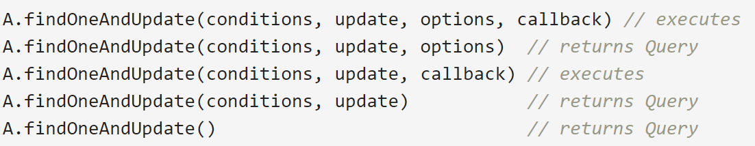

Model.findByIdAndUpdate()

Issues a mongodb findAndModify update command by a document's _id field. findByIdAndUpdate(id, ...) is equivalent to findOneAndUpdate({ _id: id }, ...).

Finds a matching document, updates it according to the update arg, passing any options, and returns the found document (if any) to the callback. The query executes immediately if callback is passed else a Query object is returned.

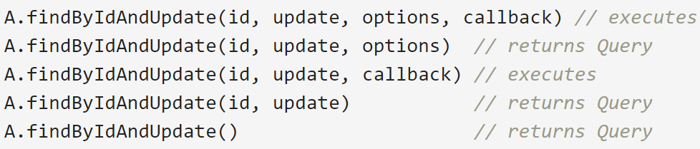

* **Removing [DELETE]**Models have a static remove method available for removing all documents matching conditions.

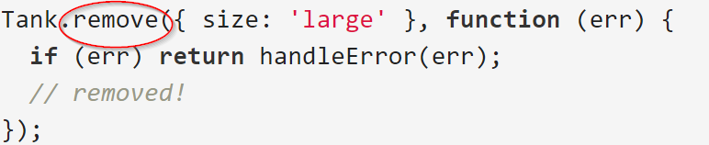

Model.remove()

Removes all documents that match conditions from the collection. To remove just the first document that matches conditions, set the single option to true.

Model.deleteOne()

Deletes the first document that matches conditions from the collection. Behaves like remove(), but deletes at most one document regardless of the single option.

Model.deleteMany()

Deletes all of the documents that match conditions from the collection. Behaves like remove(), but deletes all documents that match conditions regardless of the single option.

Model.findOneAndRemove()

Issue a mongodb findAndModify remove command.

Finds a matching document, removes it, passing the found document (if any) to the callback.

Executes immediately if callback is passed else a Query object is returned.

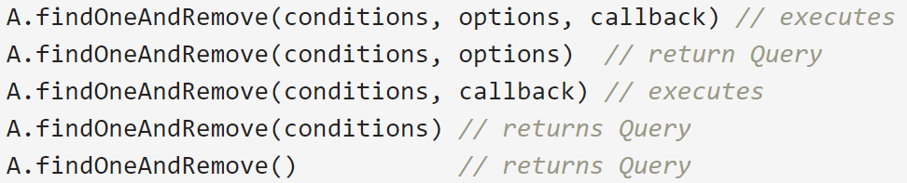

Model.findByIdAndRemove()

Issue a mongodb findAndModify remove command by a document's _id field. findByIdAndRemove(id, ...) is equivalent to findOneAndRemove({ _id: id }, ...).

Finds a matching document, removes it, passing the found document (if any) to the callback.

Executes immediately if callback is passed, else a Query object is returned.

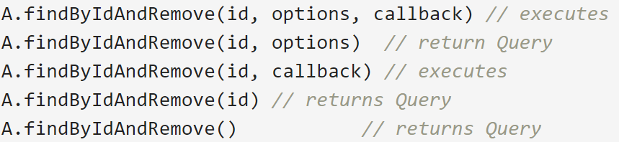

Mongoose has an exceptionally rich API that handles numerous perplexing tasks upheld by MongoDB. Consider a question where we can incrementally fabricate inquiry parts.

The API docs cover numerous extra strategies accessible like count, mapReduce, total, and so forth.

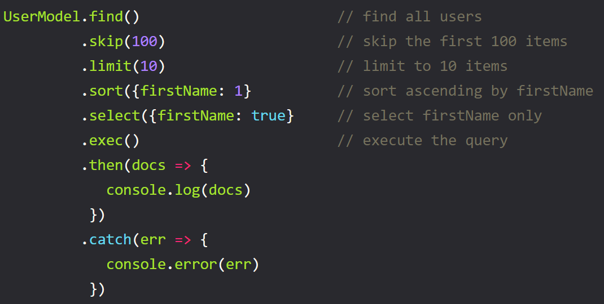

Figure 20 Query builder example

#### 2.1.3.4 Why use MongoDB?

There are a considerable measure of motivations to utilize a nosql database.

At the point when the greater part of alternate segments of your server-side application are intended to be quick and consistent, NoSQL databases keep information from being the bottleneck. Enormous information is the genuine NoSQL spark here, doing things that customary social databases can't. It?s driving the notoriety of NoSQL databases like MongoDB, CouchDB, Cassandra, and HBase. [11]

Putting away expansive volumes of information that regularly have practically no structure. A NoSQL database sets no restrictions on the kinds of information you can store together, and enables you to include distinctive new writes as your needs change. With archive based databases, you can store information in one place without defining what types of information those are ahead of time.

Benefitting as much as possible from distributed computing and storage.Cloud-based capacity is a phenomenal cost-sparing arrangement, however expects information to be effectively spread over various servers to scale up. Utilizing product (moderate, littler) equipment on location or in the cloud spares you the problem of extra programming, and NoSQL databases like Cassandra are intended to be scaled over numerous server farms out of the crate without a considerable measure of migraines.

Fast development.If you?re creating inside two-week Agile runs, wrenching out snappy cycles, or expecting to influence visit updates to the information to structure without a great deal of downtime between adaptations, a social database will back you off. NoSQL information doesn’t should be prepared early.

**MongoDB instead of MySQL?**

Associations of all sizes are receiving MongoDB on the grounds that it empowers them to assemble applications speedier, handle exceptionally different information composes, and oversee applications all the more proficiently at scale.

Advancement is streamlined as MongoDB reports outline to present day, question situated programming dialects. Utilizing MongoDB expels the intricate protest social mapping (ORM) layer that makes an interpretation of items in code to social tables. MongoDB?s adaptable information demonstrate additionally implies that your database mapping can develop with business prerequisites.[11]

MongoDB can likewise be scaled inside and over various conveyed server farms, giving new levels of accessibility and adaptability already unachievable with social databases like MySQL. As your arrangements develop as far as information volume and throughput, MongoDB scales effectively with no downtime, and without changing your application. Conversely, to accomplish scale with MySQL regularly requires noteworthy, custom building work.

Pros

* Document oriented
* High performance
* High availability — Replication
* High scalability – Sharding
* Dynamic — No rigid schema.
* Flexible – field addition/deletion have less or no impact on the application
* Heterogeneous Data
* No Joins
* Distributed
* Data Representation in JSON or BSON
* Geospatial support
* Easy Integration with BigData Hadoop
* Document-based query language that’s nearly as powerful as SQL
* Cloud distributions such as AWS, Microsoft, RedHat,dotCloud and SoftLayer etc:-. In fact, MongoDB is built for the cloud. Its native scale-out architecture, enabled by ‘sharding,’ aligns well with the horizontal scaling and agility afforded by cloud computing.

**Good for:**

* E-commerce product catalog.
* Blogs and content management.
* Real-time analytics and high-speed logging, caching, and high scalability.
* Configuration management.
* Maintaining location-based data — Geospatial data.
* Mobile and social networking sites.
* Evolving data requirements.
* Loosely coupled objectives — the design may change by over time.

#### 

#### 2.1.3.5 Reasons why we use mongoose.js

* Various database designers who begin from SQL database composes feel uncommonly cumbersome working with dynamic collections that have no structure portrayed.
* Different database planners who start from SQL database forms feel exceptionally awkward working with dynamic accumulations that have no structure depicted.
* In addition, it executes endorsement and other flawless features remembering the ultimate objective to guarantee your mapping is unsurprising while embeddings/reviving/finding chronicles from aggregations.
* It in like manner creates?Model?abstraction which makes it less requesting to work with, so doubtlessly you are working with just dissents rather than unadulterated data.
* There are numerous different treats, like middleware, plugins, population, validation.
* The grammar between the Node Driver and the Mongo shell is fundamentally the same as thus you'll get a speedier handle of how to utilize MongoDB when all is said in done.
* Models are simply useful when you are scaling into a noteworthy application with a gigantic API that ought to be isolated into a?MVC system(mongoose being your models).
* Most noteworthy Pro is that it has the data endorsement joined with it(requirements of what data you will allow to be added or to invigorate your database). It will take some work to gather that yourself.(but not THAT hard)
* It will process away by far most of the mongoDB code from the straggling leftovers of the application.
* Top reasons to Use Mongoose with MongoDB

Mongoose is a question report displaying (ODM) layer that sits over Node's MongoDB driver. On the off chance that your originating from SQL, it's like an ORM for a social database. While it's not required to utilize Mongoose with the Mongo, here are four reasons why utilizing Mongoose with MongoDB is by and large a smart thought. [11]

* Outlines: MongoDB is a denormalized NoSQL database. This makes it innately outline less as reports have changing arrangements of fields with various information writes. While this furnishes your information show with adaptability as it advances after some time, it can be hard to adapt to originating from a SQL foundation. Mongoose characterizes a composition for your information models so your reports take after a particular structure with pre-characterized information writes.
* Approval: Mongoose has worked in approval for composition definitions. This spares you from composing a bundle of approval code that you need to generally compose with the MongoDB driver.   
  By basically including things like ”required:true” in your pattern definitions, Mongoose gives out-of-the-container approvals for your accumulations (counting information writes).
* Case Methods: Mongoose gives discretionary pre and post spare tasks for information models. This makes it simple to characterize snares and custom usefulness on effective peruses/composes and so forth. You can likewise characterize custom techniques that follow up on a specific case (or report). While you can accomplish comparative usefulness with the local MongoDB driver, Mongoose makes it less demanding to characterize and sort out such strategies inside your mapping definition.
* Returning outcomes: Mongoose makes returning refreshed records or inquiry comes about less demanding. A prime illustration can be discovered with?update?queries. While the local driver restores a question with a win signal and the quantity of reports altered, Mongoose restores the refreshed protest itself so you can without much of a stretch work with the outcomes.

### 2.1.4 Angular.js



#### 2.1.4.1 Definition of Angular.js

AngularJS is a basic system for dynamic web applications which will give you a chance to utilize HTML as your layout dialect and gives you a chance to stretch out HTML's sentence structure to express your application's segments unmistakably and compactly.

AngularJS's information authoritative and reliance infusion take out a significant part of the code you would some way or another need to compose. Also, everything occurs inside the program, making it a perfect band together with any server innovation. [5]

AngularJS adopts another strategy. It endeavors to limit the impedance confound between report driven HTML and what an application needs by making new HTML builds. AngularJS educates the program new language structure through a build we call directives. Examples include:

* Data binding, as in {{}}.
* DOM control structures for repeating, showing and hiding DOM fragments.
* Support for forms and form validation.
* Attaching new behavior to DOM elements, such as DOM event handling.
* Grouping of HTML into reusable components.

Following are the advantages of AngularJS over other JavaScript frameworks: [5]

* Dependency Injection: Dependency Injection specifies a design pattern in which components are given their dependencies instead of hard coding them within the component.
* Two way data binding: AngularJS creates a two way data-binding between the select element and the orderProp model. orderProp is then used as the input for the orderBy filter.
* Testing: Angular JS is designed in a way that we can test right from the start. So, it is very easy to test any of its components through unit testing and end-to-end testing.
* Model View Controller: In Angular JS, it is very easy to develop application in a clean MVC way. You just have to split your application code into MVC components i.e. Model, View and the Controller.
* Directives, filters, modules, routes etc.

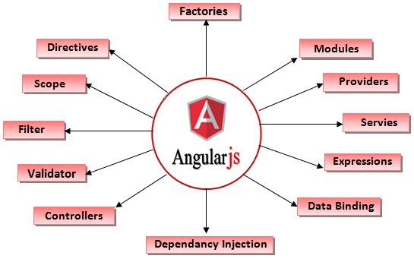

Figure 21 Overall view of Angularjs' features

#### 2.1.4.2 Understand how Angular.js works

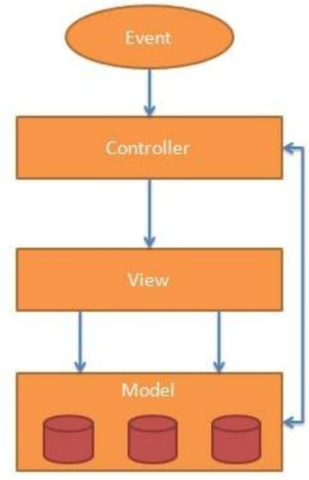

Figure 22 AngularJS MVC Architecture

AngularJS library provides different built-in modules and exposed as library methods to the web developer to build a single page web application.Below code shows the syntax of creating these SPA components in AngularJS library.

##### **Data Binding (2-way)**

Data-binding in AngularJS apps applications is the programmed synchronization of information between the model and view parts. The way that AngularJS executes information restricting gives you a chance to regard the model as the single-wellspring of-truth in your application. The view is a projection of the model constantly. [4]

When the model changes, the view reflects the change, and vice versa.

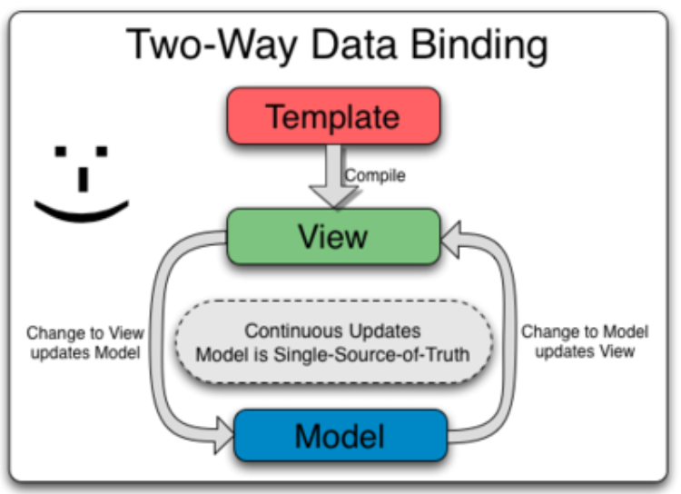

Figure 23. Two-way data binding flow

##### **Scope:**

Scope is a protest that alludes to the application model.?Scope go about as a bond amongst controller and view.

It is an execution setting for expressions. Degrees are organized in progressive structure which mirror the DOM structure of the application. Degrees can watch expressions and engender occasions.

Degrees give APIs ($watch) to watch show transformations.

Extensions give APIs ($apply) to engender any model changes through the framework into the view from outside of the "AngularJS domain" (controllers, administrations, AngularJS occasion handlers).

Coordination with the browser event loop:

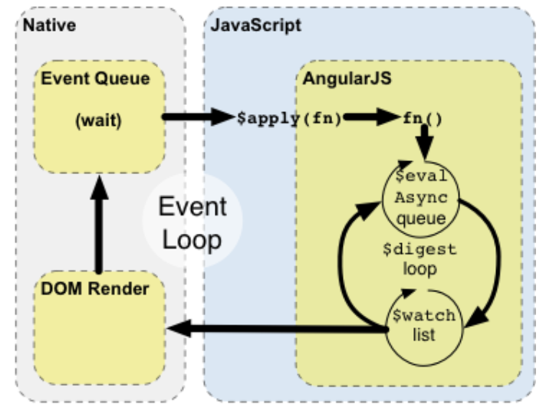

Figure 24. Scope integration with event loop

**‘$scope’** is bound by Controller. We can access $scope values in html views.

##### **Controllers**

Javascript functions are bound to a particular scope and view is bound to a particular controller. Every view needs to bind to a particular controller.

In AngularJS, a Controller is defined by a JavaScript constructor function that is used to augment the AngularJS Scope. [4]

Controllers can be attached to the DOM in different ways. For each of them, AngularJS will instantiate a new Controller object, using the specified Controller's constructor function:

the ngController directive. A new child scope will be created and made available as an injectable parameter to the Controller's constructor function as $scope, a route controller in a $route definition. [4]

The controller of a regular directive, or a component directive.

If the controller has been attached using the controller as syntax then the controller instance will be assigned to a property on the scope.

*Use controllers to:

* Set up the initial state of the $scope object.
* Add behavior to the $scope object.

Example:

We create an AngularJS Module, myApp, for our application. Then we add the controller's constructor function to the module using the .controller() method. This keeps the controller's constructor function out of the global scope.

The following example demonstrates creating a GreetingController, which attaches a greeting property containing the string 'Hola!' to the $scope:

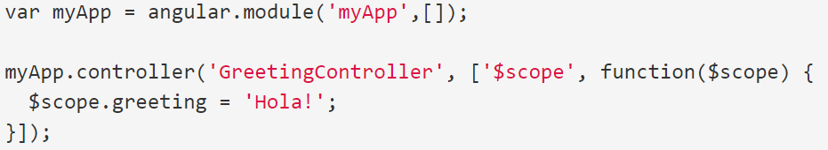

We attach our controller to the DOM using the ng-controller directive. The greeting property can now be data-bound to the template:

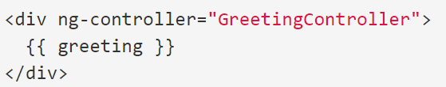

##### **Module**

Module is compartment for the distinctive parts of your application ? controllers, administrations, channels, orders, and so on. [4]

Most applications have a principle strategy that instantiates and wires together the diverse parts of the application.

AngularJS applications don't have a principle technique. Rather modules definitively indicate how an application ought to be bootstrapped. There are a few focal points to this approach:

* The declarative process is easier to understand.
* You can package code as reusable modules.
* The modules can be loaded in any order (or even in parallel) because modules delay execution.
* Unit tests only have to load relevant modules, which keeps them fast.
* End-to-end tests can use modules to override configuration.

angular.Module API

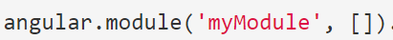

* provider(name, providerType);
* factory(name, providerFunction);
* service(name, constructor);

##### **Services:**

AngularJS has bunches of implicit administrations. [23]

For instance $http to influence an AJAX to ask. We can make our own particular administrations as per our need and access that administration in our entire app.Service are have to infuse while utilizing it.

AngularJS administrations are substitutable items that are wired together using?dependency infusion (DI). You can utilize administrations to arrange and share code over your application.

AngularJS services are:

* Lazily instantiated – AngularJS only instantiates a service when an application component depends on it.
* Singletons – Each component dependent on a service gets a reference to the single instance generated by the service factory.

**Creating Services**

Application developers are free to define their own services by registering the service's name and service factory function, with an AngularJS module.

The service factory function generates the single object or function that represents the service to the rest of the application. The object or function returned by the service is injected into any component (controller, service, filter or directive) that specifies a dependency on the service. [4]

**Registering Services**

Services are registered to modules via the Module API.

Typically you use the Module factory API to register a service:

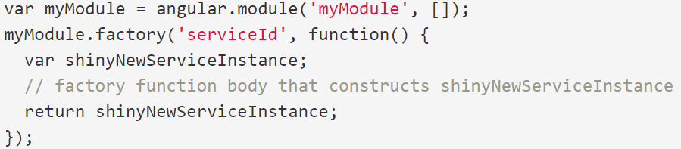

##### **Filters:**

Filtersare utilized to change data.These select a subset of things from an exhibit and returns another cluster.

Filters format the value of an expression for display to the user. They can be used in view templates, controllers or services. AngularJS comes with a collection of built-in filters, but it is easy to define your own as well.

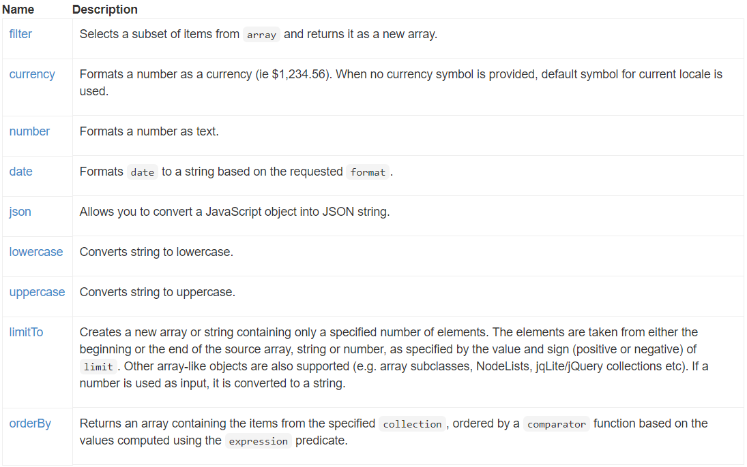

Using filters in view templates

Filters can be applied to expressions in view templates using the following syntax:

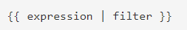

E.g. the markup {{ 12 | currency }} formats the number 12 as a currency using the currency filter. The resulting value is $12.00.

Filters can be applied to the result of another filter. This is called "chaining" and uses the following syntax:



Filters may have arguments. The syntax for this is



E.g. the markup {{ 1234 | number:2 }} formats the number 1234 with 2 decimal points using the number filter. The resulting value is 1,234.00.

When filters are executed

In formats, channels are just executed when their data sources have changed . This is more performant than executing a filter on each $digest as is the case with expressions.[4]

There are two exceptions to this rule:

In general, this applies only to filters that take primitive values as inputs. Filters that receive Objects as input are executed on each $digest, as it would be too costly to track if the inputs have changed.

Filters that are marked as $stateful are also executed on each $digest.

##### **Directives:**

Directives are a standout amongst other highlights of the AngularJS. We can make custom HTML labels and give custom conduct to labels. ngModel, ngShow, ngHide are the case of rakish is worked in mandates.

At an abnormal state, mandates are markers on a DOM component, (for example, a characteristic, component name, remark or CSS class) that tell AngularJS's HTML compiler ($compile) to append a predefined conduct to that DOM component (e.g. by means of occasion audience members), or even to change the DOM component and its kids.

AngularJS accompanies an arrangement of these orders worked in, like ngBind, ngModel and ngClass. Much like you make controllers and administrations, you can make your own particular mandates for AngularJS to utilize. At the point when AngularJS bootstraps your application, the HTML compiler traverses the DOM coordinating mandates against the DOM components.

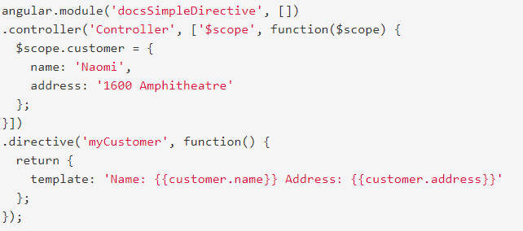

##### **Templates:**

These are the rendered view with information from the controller and model. These can be a single file or multiple views in one page using “partials”.

##### **Routing:**

For switching between views, routing is used. Built in services are available for routing.

#### 2.1.4.3 Why AngularJS?

HTML is great for declaring static documents, but it falters when we try to use it for declaring dynamic views in web-applications.

🡺AngularJS lets you extend HTML vocabulary for your application. The resulting environment is extraordinarily expressive, readable, and quick to develop. [4]

* Advantages
* AngularJS gives office to create dynamic Single Page Application by composing code in a spotless and viable way.
* AngularJS gives two way information restricting offices. DOM control is simple due to this element.
* AngularJS bolsters reliance infusion that causes engineer to reuse segment.
* AngularJS gives reusable parts.
* Designer can compose least code and accomplish greater usefulness.
* AngularJS applications can keep running on every significant program and stages like ?Android and iOS based telephones/tablets.
* AngularJS is kept up by Google. So there is substantial improvement group.

### 2.1.5 The components stack up for the project

Because all components of the MEAN stack support programs are written in JavaScript, MEAN applications can be written in one language for both server-side and client-side execution environments.

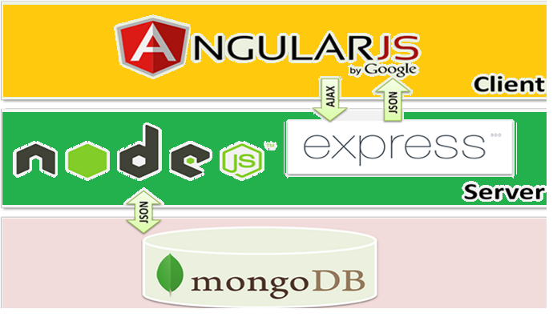

Figure 25 Project stacking up using the above components



Figure 26 Detailed features of components

## 2.2 Related components

### 2.2.1 NPM (Node Package Manager)



#### 2.2.1.1 NPM definition

Npm is a bundle administrator for Node.js with a huge number of bundles. Despite the fact that it creates some of your index structure/association, this isn't the primary reason.

The principle objective, as you touched upon, is mechanized reliance and bundle administration. This implies you can specify the greater part of your undertaking's dependencies inside your package.json file, at that point whenever you (or any other person) needs to begin with your task they can just run npm installand instantly have the majority of the conditions introduced. Over this, it is likewise conceivable to indicate what versions your venture relies on to keep refreshes from breaking your undertaking.

The NPM program is installed on your computer when you install Node.js

A package in Node.js contains all the files you need for a module.

Modules are JavaScript libraries you can include in your project.

#### 2.2.1.2 Understand npm

NPM is basically a repository of libraries you can use in your project.

Use npm to::

* Adjust bundles to your applications, or consolidate them as they may be.
* Download independent instruments you can utilize immediately.
* Run bundles without downloading using?npx.
* Offer code with any npm client, anyplace.
* Confine code to particular engineers.
* Shape virtual groups (organizations).
* Deal with different variants of code and code conditions.
* Refresh applications effectively while hidden code is refreshed.
* Find different approaches to unravel a similar astound.
* Find different designers who are taking a shot at comparable issues.

The best way to manage locally installed npm packages is to create a package.json file.

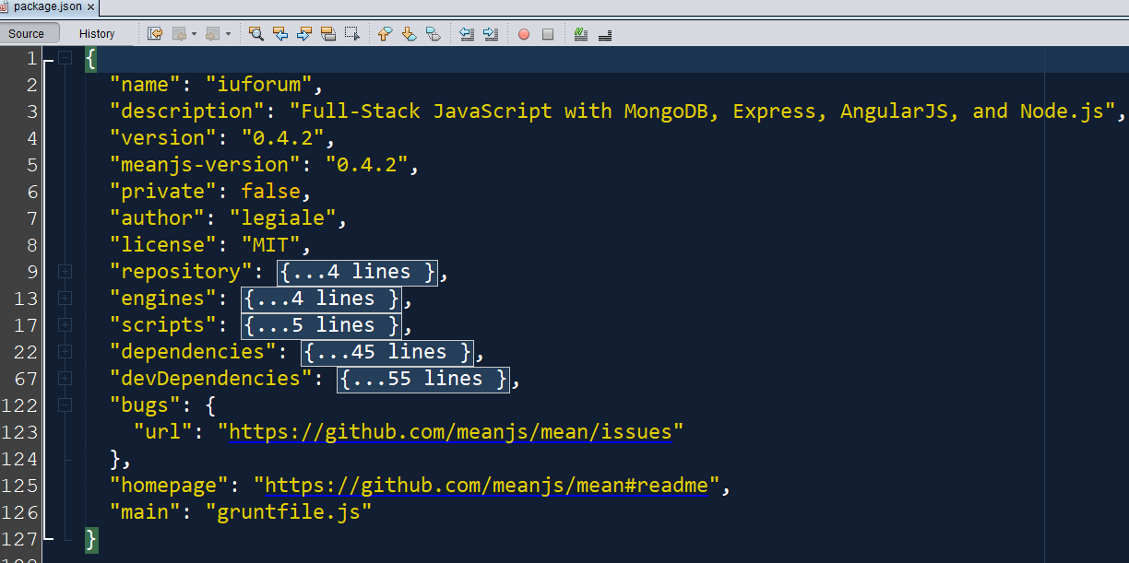

Figure 27 Example NPM json file

#### 2.2.1.3 Why do we need npm

The major benefits are:

* It handles recursive dependencies
* The dependencies can be re-constituted as needed and don't need to be stored in your own repository -- 'cause storing other peoples' code is a real drag
* Easily specify and change which version of these packages you depend on

### 2.2.2 Bower

### 

#### 

#### 2.2.2.1 Bower definition

Bower is a bundle chief for the web. It offers a bland, un-stubborn answer for the issue of front-end bundle administration, while uncovering the bundle reliance display through an API that can be devoured by a more obstinate form stack. There are no framework wide conditions, no conditions are shared between various applications, and the reliance tree is level.

Arbor deals with every one of these structures, libraries, resources, and utilities for you.

Monitoring every one of these bundles and ensuring they are up and coming (or set to the particular variants you require) is dubious. Grove to the safeguard!

🡺 pretty much the same as npm

-Bower is created solely for the front-end and is optimized with that in mind.

-The biggest difference is that npm does nested dependency tree (size heavy) while Bower requires a flat dependency tree (puts the burden of dependency resolution on the user).

the main difference between both is npm is used for installing Node js modules but bower js is used for managing front end components like html, css, js etc.

#### 2.2.2.2 Why we use bower

Front-End needs a Package Manager

Bower is made exclusively for the front-end and is upgraded because of that. The greatest distinction is that npm does settled reliance tree (estimate substantial) while Bower requires a level reliance tree (puts the weight of reliance determination on the client).

Bower doesn't recommend to the client its own particular form framework, or to the engineer a technique for including libraries (AMD, CommonJS, and so on.) All Bower does is introduce the correct variants of the bundles that the undertaking needs and their conditions. As it were: it downloads source documents for the correct libraries and all that they require into an extraordinary envelope. Everything else is up to the engineer.

#### 2.2.2.3 Why not npm?

The principle contrast amongst npm and Bower is the approach for introducing bundle conditions. npm introduces conditions for each bundle independently, and accordingly influences a major bundle reliance to tree (node_modules/snort/node_modules/glob/node_modules/...), where there could be a few rendition of a similar bundle. For customer side JavaScript this is inadmissible: you can't include two diverse adaptation for jQuery or some other library to a page. With Bower each bundle is introduced once (jQuery will dependably be in the bower_components/jquery organizer, paying little heed to what number of bundles rely upon it) and on account of a reliance strife, Bower basically won't introduce the bundle inconsistent with one that is as of now introduced.

**So is there really anything about it that technically makes it more adapted for client-side modules?”**

The short answer is yes. The primary technical difference between NPM modules and Bower modules is how they can consumed.

NPM stands for “Node Package Manager”, so while NPM modules can be used for a number of uses, most are intended to operate within the Node.js ecosystem. NPM modules can include a “main” file specification which allows you to “export” a JavaScript object by assigning it as “module.exports”. This module can then be “imported” into another module or file by using require(“module name”). NPM modules will find each other as long as they are located in the correct location based on NPM naming conventions and this is best done by installing with the command “NPM INSTALL”. Because of this modular design, NPM modules need all of the required dependencies to run. Therefore when you install an NPM module, you also install all dependent code. This can often be thousands of individual files. Regardless of whether you use Node.js or Browserify, you will need all of this code in order to execute this “main” module. Node.js loads all of these files from the file system and Browserify packages them into one or more files to load in your browser. When NPM packages are deployed to a repository, the content is stored in the repository. This makes it easy to control what gets deployed with the package and this content can be built from the source code and then deleted since the published package is stored in the repository.

Bower modules can also specify one or more “Main” files, but these perform no technical purpose. Unlike NPM, Bower is not tied to any specific ecosystem. So when Bootstrap specifies “less/bootstrap.less” as one of its main files, you have to know that you will need to use this as an entry-point for LESS processing for this to have any meaning. How (or if) you process this LESS file is up to you. Most likely what you really want is the pre-processed CSS files in the “dist/css” folder and you want to get the other content such as fonts and you want that content to be in the correct file structure for use with the CSS. It is up to you (usually by reading the documentation for the package) to determine how to use this content (typically with an HTML tag in a web application).

Similarly to NPM, Bower also allows you to specify dependencies which can be installed automatically using “BOWER INSTALL”. However, because Bower modules are typically intended to be used for client-side (i.e. just include a tag to use the content), the number of dependencies are typically smaller and in some cases could even be “soft” dependencies meaning they are not installed automatically but if you want to use a certain feature you can install and use them. Using dependencies is not automatic since you typically need to add them to your HTML by placing a tag prior to the tag for the module that depends on them.

Bower packages are NOT stored in the repository. Bower assumes that the package contents are in a GIT repository. Therefore you cannot just build the package content and then delete it after deploying. You must store the packaged content in the GIT repository.

### 2.2.3 Passport.js

### 

#### 2.2.3.1 Definition of Passport.js

Passport.js is an flexible authentication middleware for express based node.js applications.

That means passport.js module handles all session controls, login / logout / register. [21]

You can use it to enable email/password authentication or even social logins like login with facebook, twitter, instagram and the likes, and also login with services like pocket, dropbox, meetup, zendesk …..etc (there’s a host of them)

Procedures with local & online (there are tons) strategies with the way you use it.

Passport.js is a simple, unobtrusive Node.js authentication middleware for Node.js. It can be dropped into any Express.js-based web application.

#### 2.3.2 Understand Passport.js’ flow

* With the tree parts configured as in the example, the following happens when a user tries the authentication via the /login route: [21]

1. At the point when the client presents the login frame, a POST request to /login is made bringing about the execution of the passport.authenticate middleware we've set up.

2. As the verify middleware for that course is designed to deal with the local strategy, identification will summon our execution of the nearby procedure.

3. International ID takes the req.body.username and req.body.password and passes it to our check work in the nearby methodology.

4. Presently we do our thing: stacking the client from the database and checking if the secret word given matches the one in the database.

5. If there should arise an occurrence of an Error interfacing with our database, we have to invoke done(err). When we can't discover the client or the passwords don't watch, we invoke?done(null, false). On the off chance that everything went fine and we need the client to login we invoke?done(null, client).

6. Calling done will influence the stream to hop back into?passport.authenticate. It's passed the mistake, client and extra data question (if characterized).

7. In the event that the client was passed, the middleware will call?req.login?(a identification work appended to the demand).

8. This will call our passport.serializeUser method we've characterized before. This technique can get to the client protest we go back to the middleware. Its must figure out what information from the client question ought to be put away in the session. The consequence of the serializeUser method is connected to the session a req.session.passport.user = {/our serialized client protest/}.

9. The outcome is likewise connected to the demand as?req.user.

10. Once done, our requestHandler is conjured. In the illustration the client is diverted to the landing page.

* *Where does user.id follow passport.serializeUser has been called? [21]

The client id (you give as the second contention of the?done?function) is spared in the session and is later used to recover the entire protest by means of the deserializeUser function.

serializeUser determines, which information of the client protest ought to be put away in the session. The consequence of the serializeUser strategy is appended to the session as req.session.passport.user = {}. Here for example, it would be (as we give the client id as the key) req.session.passport.user = {id:'xyz'}

We are calling passport.deserializeUser directly after it where does it fit in the work process?

The principal contention of deserializeUser corresponds to the key of the client question that was given to the done function (see 1.). So your entire question is recovered with help of that key. That key here is the client id (key can be any key of the client protest i.e. name,email and so forth). In deserializeUser that key is coordinated with the in memory cluster/database or any information asset.

The brought question is appended to the demand protest as req.user[21]

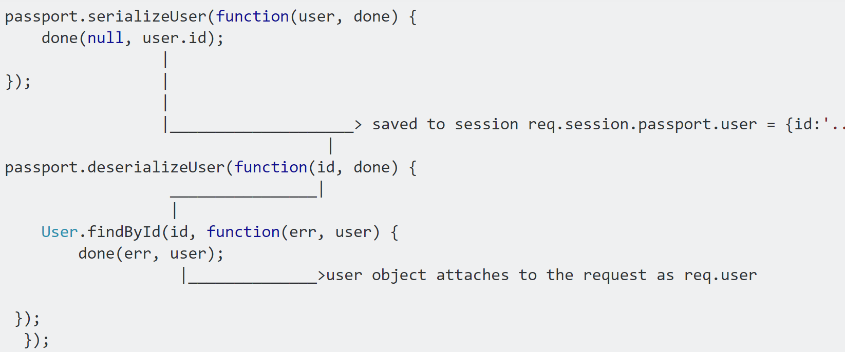

Figure 28 Passport.js work flow

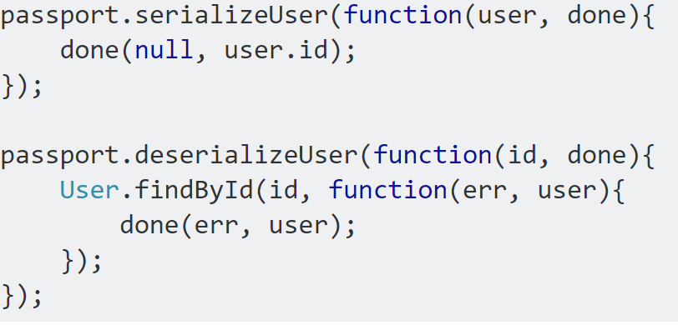

Figure 29 Passport.js serialize and de-serialize

**Summary passport methods and middleware**

* passport.initialize middleware is invoked on every request. It ensures the session contains a passport.user object, which may be empty.
* passport.session middleware is a Passport Strategy which will load the user object onto req.user if a serialised user object was found in the server.
* passport.deserializeUser is invoked on every request by passport.session. It enables us to load additional user information on every request. This user object is attached to the request as req.user making it accessible in our request handling.
* Local Strategy is only invoked on the route which uses the passport.authenticate middleware.
* Only during this authentication passport.serializeUser is invoked allowing us the specify what user information should be stored in the session.

#### 

#### 2.2.3.3 Advantage of using Passport.js

* First of all it is very simple to use. Easy for integration with frameworks like Express.js 🡺It automates the login construction
* Another advantage of PassportJS is that it supports login via Facebook, Twitter, or Google account. 🡺OAuth, OpenId or other authentication methods which is already ready in passport then sure, use it!
* Passport employs a strategy design pattern to define a clear separation of concerns between the core module and various authentication mechanisms. This has a number of benefits, including smaller overall code size and well defined and testable interfaces.

### 2.2.4 Grunt.js (The JavaScript Task Runner)



#### 2.2.4.1 Definition

Grunt is a javascript task runner tool. You can do a lot of things using grunt which you had to do manually otherwise. Highlighting some of the uses of Grunt:

Zipping some files (e.g. zipup plugin)

Linting on js files (jshint)

Compiling less files (grunt-contrib-less)

There are grunt plugins for sass compilation, uglifying your javascript, copy files/folders, minifying javascript etc.

Please Note that grunt plugin is also an npm package.

The basic principle for Grunt is to give us an easy way to run tasks. A task is a set of code files and configuration files already created for you. You can get new tasks by installing Grunt plugins that you will get using npm. You can find a plugin for pretty much every tool you might use, such as Less and JSHint.

#### 2.2.4.2 How Grunt.js works?

With this in mind consider the following scenarios:

If you know about the advantages of SASS (or LESS) and use it very frequently, everytime you change your SASS/LESS files you have to recompile them manually.

Before releasing your product you may want to increase its performance by minifying your javascript and css code - you may use some online tools like cssminifier.com and similar.

Since you (and your team) want to write good code you're probably using linters like for your css, js and so on. Those linters have to be run after every single change in the corresponding files.

To ship your product you'd like to compress it into a single archive. To do this, you have to mark all files which belong to your application (or whatever you've written) and zip them. For every release. And, even worse, sometimes you have to deal with these annoying .DS_Store (OS X) or Thumbs.db (Windows) files within your archives.

To increase the performance of your app even further you'd like to concatenate all your js or css files into a single file. Honestly, I have no idea how to do that without a task runner, sorry.

If you're developing web app or even a website, most of the times you change something you have to reload the page by pressing refresh or hitting ctrl + r (f5 if you have long fingers). On every device, on every browser.

For using Grunt we need two additional files:

* one for Node/npm (package.json)
* the Grunt configuration file (Gruntfile.js)

The package.json is used for the node package manager, npm, and just contains a list of our dependencies:

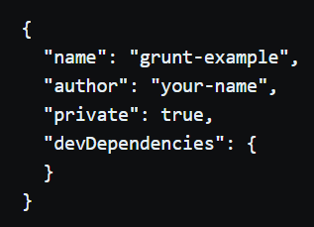

We need the following packages:

* A task to watch files for changes: grunt-contrib-watch
* A task to autoprefix our css: grunt-autoprefixer (This grunt plugin is marked as deprecated and moved to grunt-postcss, which can do even more things than "just" autoprefixing. But because of simplicity we'll still use it.)
* And, of course, grunt itself.
* 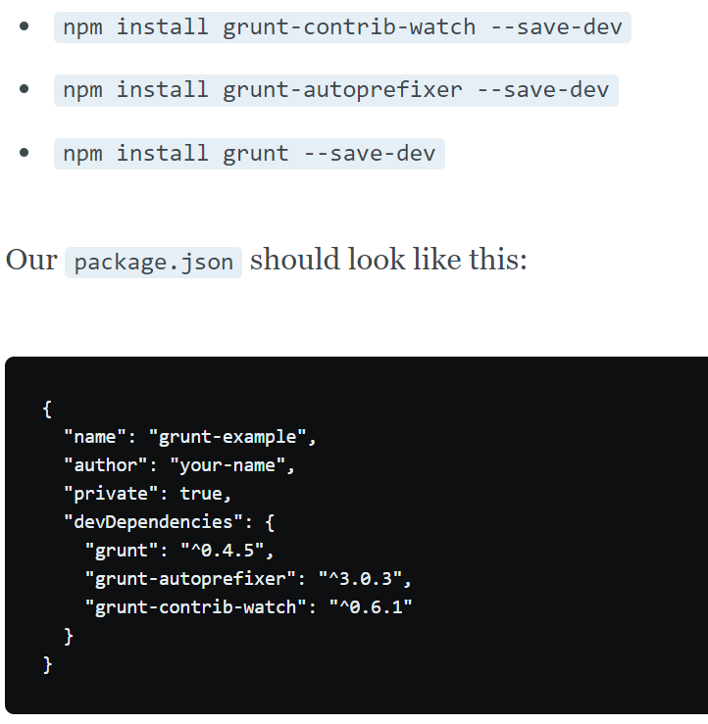

Figure 30 package.json example after installing grunt

If you run grunt with no options now, we’ll run the default task, if one has been set. In the case of a jQuery plugin project, that’s equivalent to running these four commands:

* grunt lint: checks your JavaScript against JSHint
* grunt qunit: runs your Qunit tests
* grunt concat: concatenates your project files together and puts the new file in a dist folder
* grunt min: minifies the file concat put out.

#### 2.2.4.3 Why use Grunt?

The Advantage vs shell script:

If you write shell script for every one of these tasks, it is tedious to maintain and then customize for every one of your needs. Gruntfile.js is actually pretty easy. there is a config that you init it with, specifying what tasks you want to perform, the sources and targets for each.

The integration with project seed generators on Yeoman, Gulp is another major factor to consider. Yeoman and Gulp come with Gruntfile.js' with intelligent defaults. For someone who is the sole UI contributor on his team, this is priceless to me!

For someone who is working on frontend technologies, if you have more than one person working with you, its rather easy for them to get to know Grunt, which is already well documented with a lot of answers on SO, than to get to know your shell scripts. This might be a factor in large teams.

The numerous plugins for Grunt extend base functionality. Unless your shell script is VERY popular, and VERY modular, I dont see plugins being built for it. This also extends to inclusion of new front end technologies in your project. Say, if you want to use typescript in your project tomorrow, your shell script will need to incorporate this and account for it with your own effort. With Grunt, its just as simple as "npm install " and adding a config.

### 2.2.5 Nodemon (Auto-Watch-Reload Node.js file)



#### 2.2.5.1 What is Nodemon?

Nodemon is a utility that monitors for any changes in the development source files and automatically restart the server whenever a code change happens.nodemon will watch the files in the directory and if there is a change in the files,it will automatically restart the node application.It does not look for any changes made in the source code of development. By issuing the below command we install nodemon

Just use nodemon instead of node to run your code, and now your process will automatically restart when your code changes.

#### 2.2.5.2 How nodemon works?

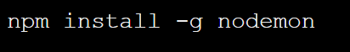

Features

* Automatic restarting of application.
* Detects default file extension to monitor.
* Default support for node but easy to run any executable
* Ignoring specific files or directories.
* Watch specific directories.
* Works with server applications or one time run utilities and REPLs.
* Requirable in node apps.

### 

### 2.2.6 Socket.io



#### 2.2.6.1 What is socket.io?

Socket.IO is a JavaScript library for real-time web applications.

It enables realtime, bi-directional communication between web clients and servers. It has two parts: a client-side library that runs in the browser, and a server-side library for Node.js. Both components have a nearly identical API. Like Node.js, it is event-driven. [15]

Socket.IO primarily uses the WebSocket protocol with polling as a fallback option, while providing the same interface. Although it can be used as simply a wrapper for WebSocket, it provides many more features, including broadcasting to multiple sockets, storing data associated with each client, and asynchronous I/O.

It can be installed with the npm tool.

* Binary streaming support
* Improved support for horizontal scaling
* Removal of cluttered debug messages in the console by default
* Support for Node.js streams via the socket.io-stream module

#### 2.2.6.2 How socket.io works?

Socket.IO provides both server-side and client-side components with similar APIs.

**Server-side**

On the server-side, Socket.IO works by adding event listeners to an instance of http.Server.

To add Socket.IO support to a http.Server instance:

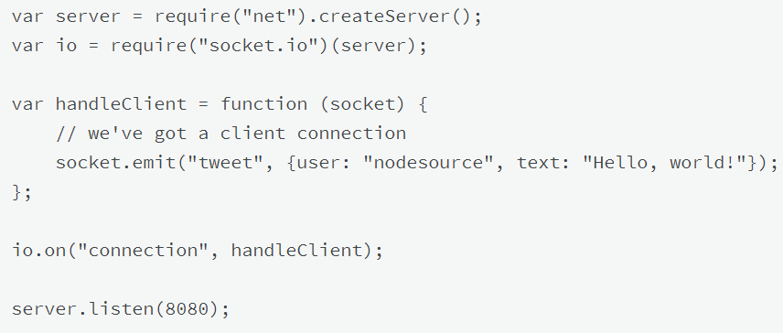

Figure 31 Initialize socket.io

with Express:

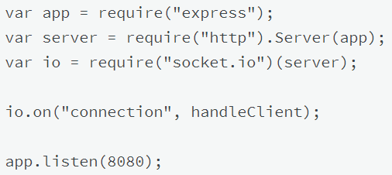

Figure 32 socket.io with express.js

* **Client-side**

The HTTP server will begin to serve the client library at /socket.io/socket.io.js.

To connect to Socket.IO server, we need to put the following in our body tag

* **Sending and Receiving Objects**

Since both the server and client's Socket object act as EventEmitters, you can emit and listen for events in a bi-directional manner. For example, we can emit a "tweet" event on the server and listen for it on the client side [15]

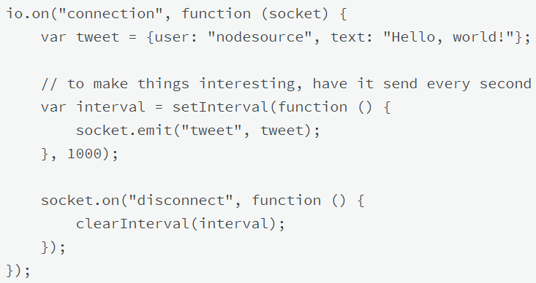

To consume the data in the browser, we need to listen for the "tweet" event.

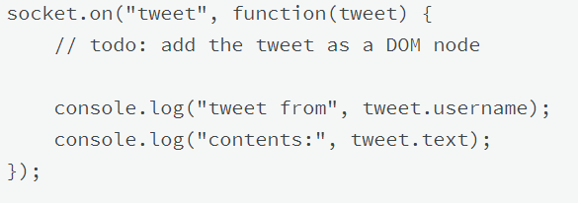

#### 2.2.6.3 Why use socket.io?

* Match good with node.js
* It handles graceful degradation for you to numerous technical alternatives to get bi-directional near-time communication flowing (web sockets, ajax long polling, flash, etc)
* It handles browser inconsistencies and varying support levels for you
* (these first 2 things are basically the same value created by jQuery, to put it in perspective)
* It includes additional features beyond bare bones web sockets such as room support for basic publish/subscribe infrastructure and things like automatic reconnect
* AFAIK it is more popular and easier to get help with than vanilla web sockets, at least at the moment.

## 2.3 Sum-up Project’s technology background



With other extra components

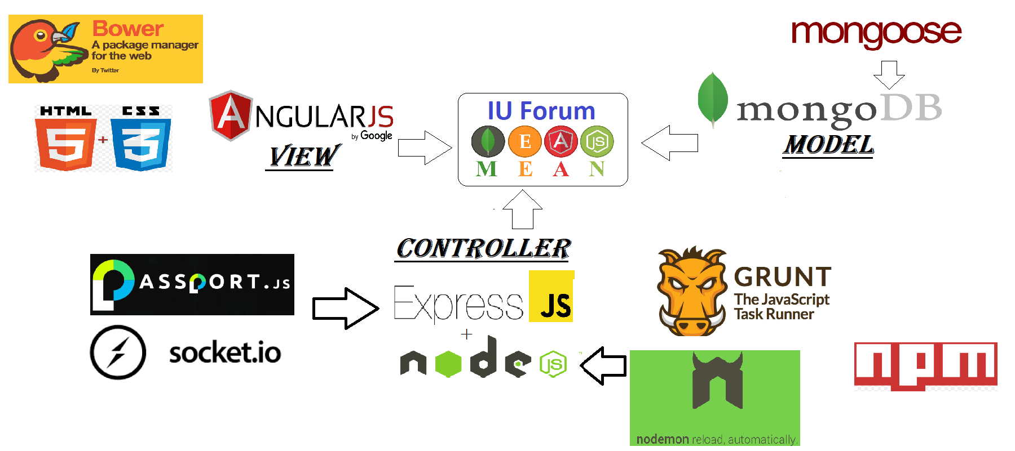

# 

# Chapter III System requirements

I want to use the MEAN stack to build an academic forum.

So basically there will be 2 groups of user in my project

The first group will be the normal ones including : **user (visitor), member, tutor.**

The second will be the administrative one including: **Moderator, Forum owner**

### 3.1 Usecases by user-stories

-List of features and functions described by user stories:

**Theme 1: user (visitor), member, tutor.**

1. Display informative homepage

|  |  |
| --- | --- |
| *As a* | forum user |
| *I want to* | see an informative & well-structured-layout homepage whenever I visit the forum |
| *so that I can* | easily understand and use all the functions offered by the forum as well as look for the objects that I am interested in. |

1. Membership register

|  |  |
| --- | --- |
| *As a* | forum user |
| *I want to* | register an user account for forum-membership (both manually and via social networks like facebook or google plus) |
| *so that I can* | experience all features provided for members as well as identify myself whenever I participate in any forum’s activities. |

1. User sign in/log out

|  |  |
| --- | --- |
| *As a* | forum member |
| *I want to* | Sign-in/log-out with my registered account |
| *so that I can* | easily manage my membership and use it to interact with the forum features. |

1. Tutor-role registration request

|  |  |
| --- | --- |
| *As a* | forum member |
| *I want to* | Make request to register myself as a tutor  (change my account role from ordinary membership into tutor) |
| *so that I can* | Identify myself as a tutor whenever I participate in any activities of the forum and have access to all the functions provided for forum tutors. |

1. User manage profiles

|  |  |
| --- | --- |
| *As a* | forum member |
| *I want to* | edit my account’s information |
| *so that I can* | easily manage my profile as well as personal information. |

1. Search engine

|  |  |
| --- | --- |
| *As a* | forum user |
| *I want to* | Use the search tool |
| *so that I can* | Find all the items and topics of the forum that I am interested in by inputting keywords or filtering categories. |

1. View threads/items

|  |  |
| --- | --- |
| *As a* | forum user |
| *I want to* | View all the posted threads or items that I concern about by clicking their tittles. |
| *so that I can* | See every details of those items (like authors, post date, category, content, etc). |

1. Comments

|  |  |
| --- | --- |
| *As a* | forum member |
| *I want to* | Post my comments on every threads or issues as well as edit or delete my comments whenever necessary |
| *so that I can* | Express my opinions or point of view on the issues that I am interested in. |

1. Post new threads/ share resources

|  |  |
| --- | --- |
| *As a* | forum member |
| *I want to* | Post new threads/items on the sub-forums or specific categories |
| *so that I can* | Interact with all other members via comments or messages about the posted subjects. |

1. Download shared resources

|  |  |
| --- | --- |
| *As a* | forum user/member |
| *I want to* | Be able to download all the shared resources posted/uploaded by other forum members |
| *so that I can* | Find everything that satisfy my needs through the forum. |

1. Chat-room

|  |  |
| --- | --- |
| *As a* | forum member |
| *I want to* | Join the hosted chat-rooms |
| *so that I can* | Communicate and exchange my points of view with all other forum members that are interested in the same subjects (specified in the chat-rooms) |

1. Private message

|  |  |
| --- | --- |
| *As a* | forum member |
| *I want to* | Send/receive private messages with other members via private-message system |
| *so that I can* | Exchange personal opinions with a particular person |

1. Join video live streaming

|  |  |
| --- | --- |
| *As a* | forum user/member |
| *I want to* | Participate in live-streams hosted by forum members (with chatbox included) |
| *so that I can* | Watch and gain information about the subjects of the live-streams that I am interested in as well as exchanging opinions with all other forum members in the process. |

1. Make requests for not-yet-available resources

|  |  |
| --- | --- |
| *As a* | forum member |
| *I want to* | post new request to ask for the resources (documents, tutor courses, etc) that have not been provided on the forum yet and make payment in return |
| *so that I can* | Achieve my needs for the wanted resources. |

1. See list of available tutoring courses

|  |  |
| --- | --- |
| *As a* | forum user |
| *I want to* | See list of available tutoring courses offered by forum tutors, filtered by tags or categories |
| *so that I can* | Easily select the courses that suit my needs. |

1. Post offer for rare resources

|  |  |
| --- | --- |
| *As a* | forum member |
| *I want to* | Post a not-yet-available resources offer along with a payment requirement |
| *so that I can* | Inform other members who currently need that resources to interact with my offer as well as earn their payment |

1. Open a tutoring-course offer

|  |  |
| --- | --- |
| *As a* | forum tutor |
| *I want to* | Open a tutoring course offer (maybe along with a payment requirement) |
| *so that I can* | Inform other members who currently need that course to interact with my offer (as well as earn their payment). |

1. Make cash charges

|  |  |
| --- | --- |
| *As a* | forum member |
| *I want to* | Make charges via third-party cards |
| *so that I can* | Have balance in my forum account in order to interact with the resource offers or tutoring courses which requires payment. |

1. Make payment

|  |  |
| --- | --- |
| *As a* | forum member |
| *I want to* | Make payments to the offers I select using my account balance |
| *so that I can* | Achieve my needs from those offers. |

1. View activity log

|  |  |
| --- | --- |
| *As a* | forum member |
| *I want to* | View a clearly-noted history log page of all the activities that I participated in using my account (comments, threads, courses, live-stream, payment, cash charges, etc) |
| *so that I can* | Keep track of all the interactions I made. |

1. Notification system

|  |  |
| --- | --- |
| *As a* | forum member |
| *I want to* | Receive notifications about all the threads/ items of the forum that I have concerned or made interactions with |
| *so that I can* | Keep track on everything going on about the issues that I am interested in. |

1. Rate/ like the resources of the forum

|  |  |
| --- | --- |
| *As a* | forum user |
| *I want to* | Like, rate the resources in the forum |
| *so that I can* | Give my judgment about that resource and inform everyone about that resource’s quality. |

1. Report a forum member on his/her courses

|  |  |
| --- | --- |
| *As a* | forum tutor |
| *I want to* | Report the fault of members who is currently participating is my courses |
| *so that I can* | Keep the best quality of my courses ma make sure the learning-offering process is clean. |

**Theme 2 : Moderator & Administrator**

1. Management Dashboard for CRUD operations

|  |  |
| --- | --- |
| *As a* | forum Moderator/Administrator |
| *I want to* | Have access to the management dashboard |
| *so that I can* | Perform administrative methods via CRUD operation over forum’s resources. |

1. Confirm the tutor-role requests

|  |  |
| --- | --- |
| *As a* | forum Admin |
| *I want to* | See and confirm all requests of forum members wanting to have tutor role |
| *so that I can* | Check if the requested members are well-qualified enough for the tutor role. |

1. Manage (confirm/delete) the posted threads and comments of members

|  |  |
| --- | --- |
| *As a* | forum Moderator |
| *I want to* | Have permission to confirm/delete the posted threads and comments of members |
| *so that I can* | Make sure that all threads and comments of members follow the regulations of the forum. |

1. Promote/Demote Moderator

|  |  |
| --- | --- |
| *As a* | forum Administrator |
| *I want to* | Change the role of normal forum members into ‘Moderator’ role and vice versa |
| *so that I can* | Perform the promote or demote features to whoever that fits the needs of in-charging of managing sub forums. |

1. Statistic tracking tools

|  |  |
| --- | --- |
| *As a* | forum Moderator/Administrator |
| *I want to* | Be able to check the statistic and numeric data of all resource in the forum that I manage |
| *so that I can* | Keep track by numeric data of the entire activity of the specific forum that I am responsible for. |

1. PDF/xslx report export

|  |  |
| --- | --- |
| *As a* | forum Moderator/Administrator |
| *I want to* | be able to export a pdf or excel format of report when in the statistic-management screen |
| *so that I can* | easily complete the monthly/weekly report. |

### 3.2 Diagrams

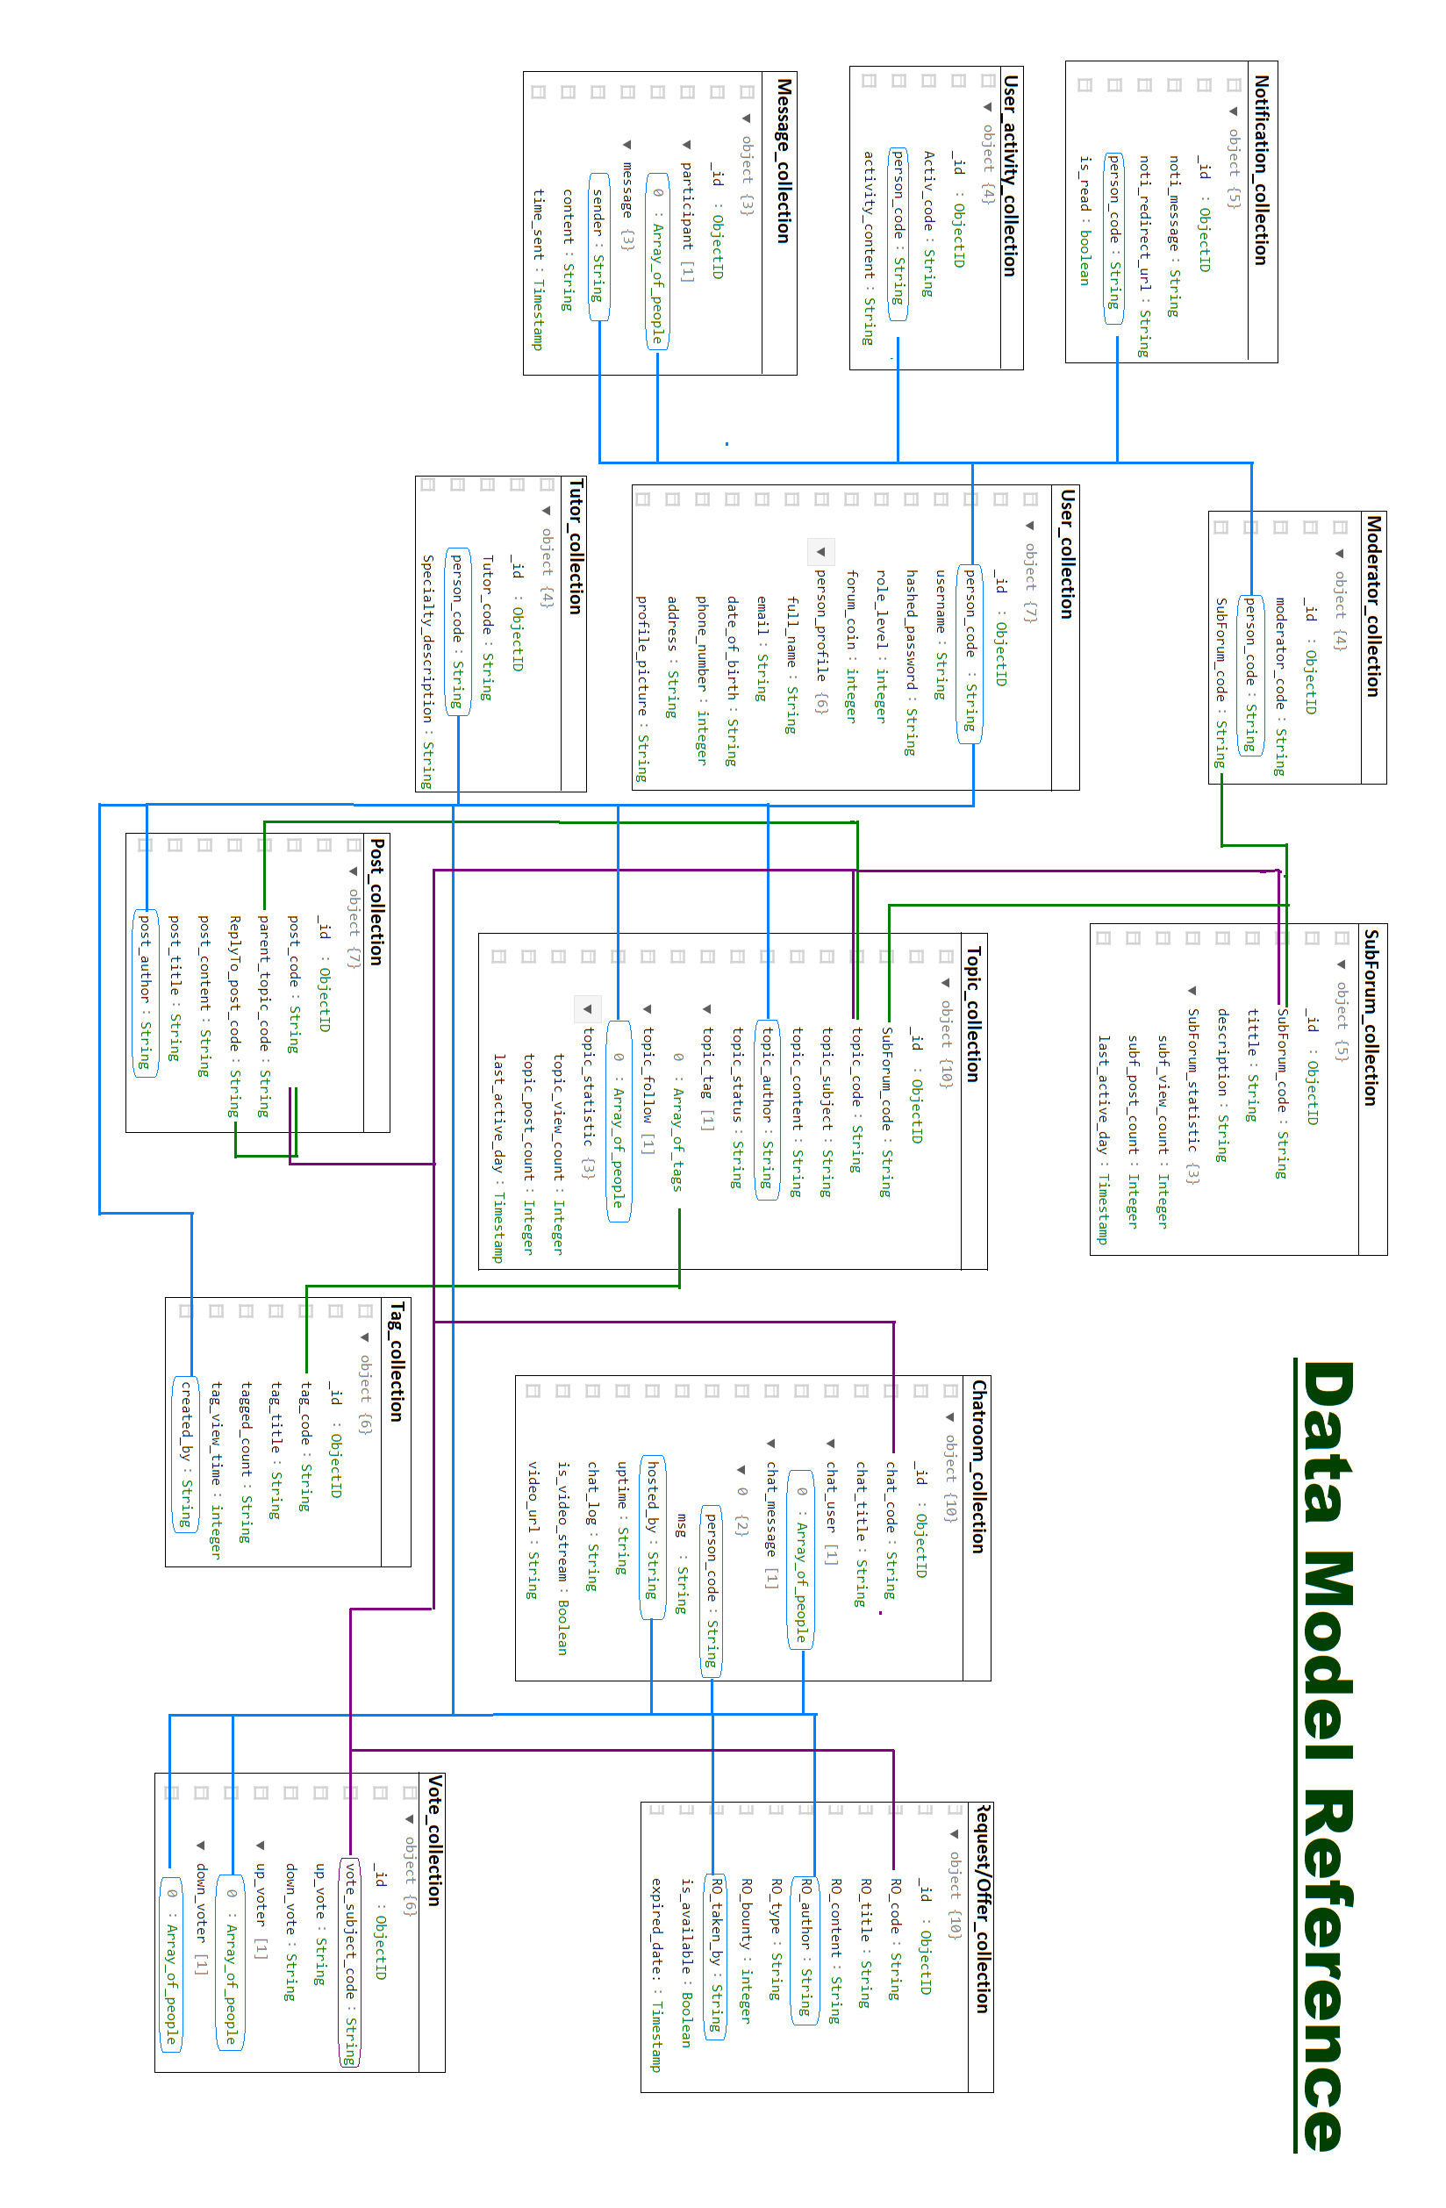

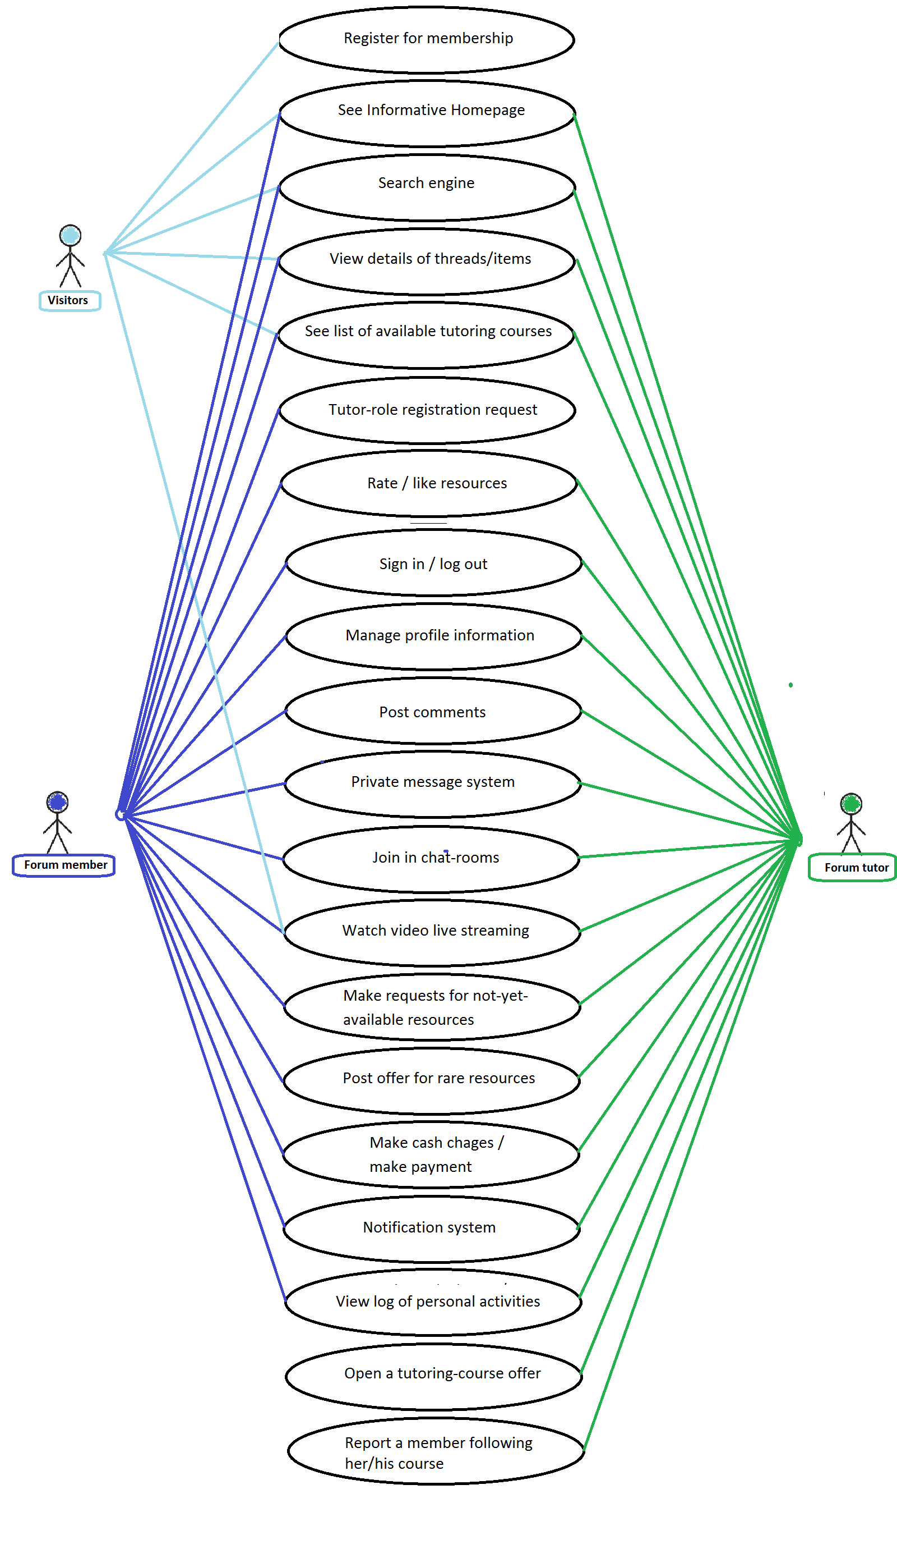

Figure 33 Usecase Diagram for theme-1

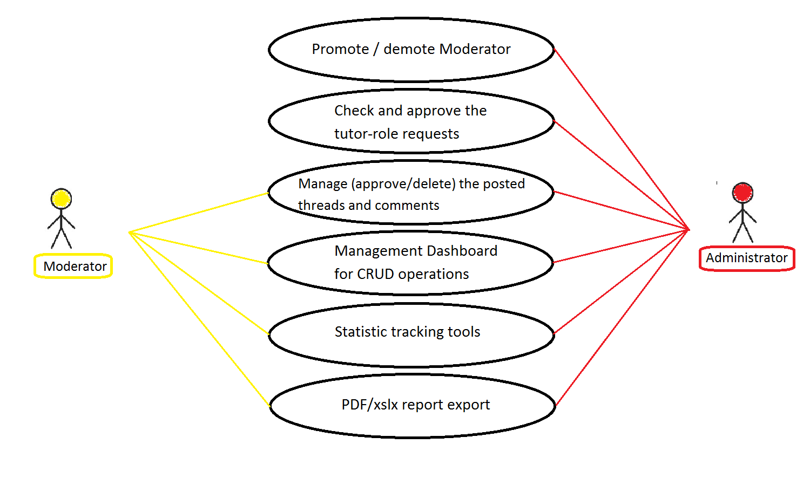

Figure 34 Usecase diagram for theme-2

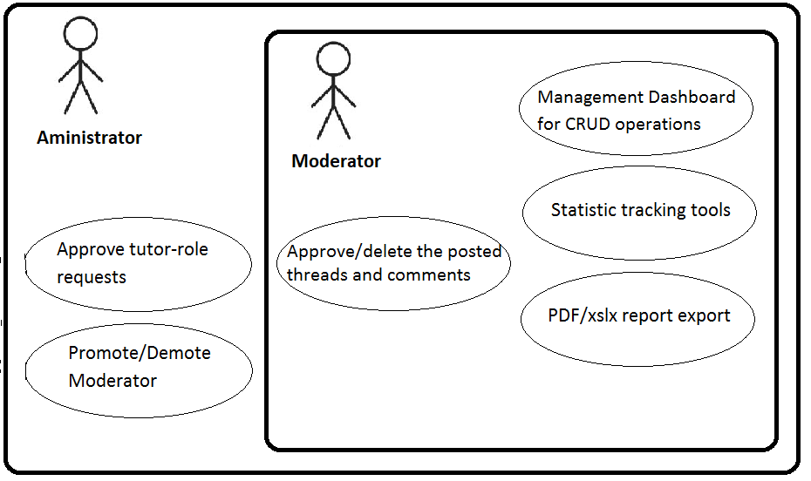

Figure 35 Use-case Hierarchy theme 1

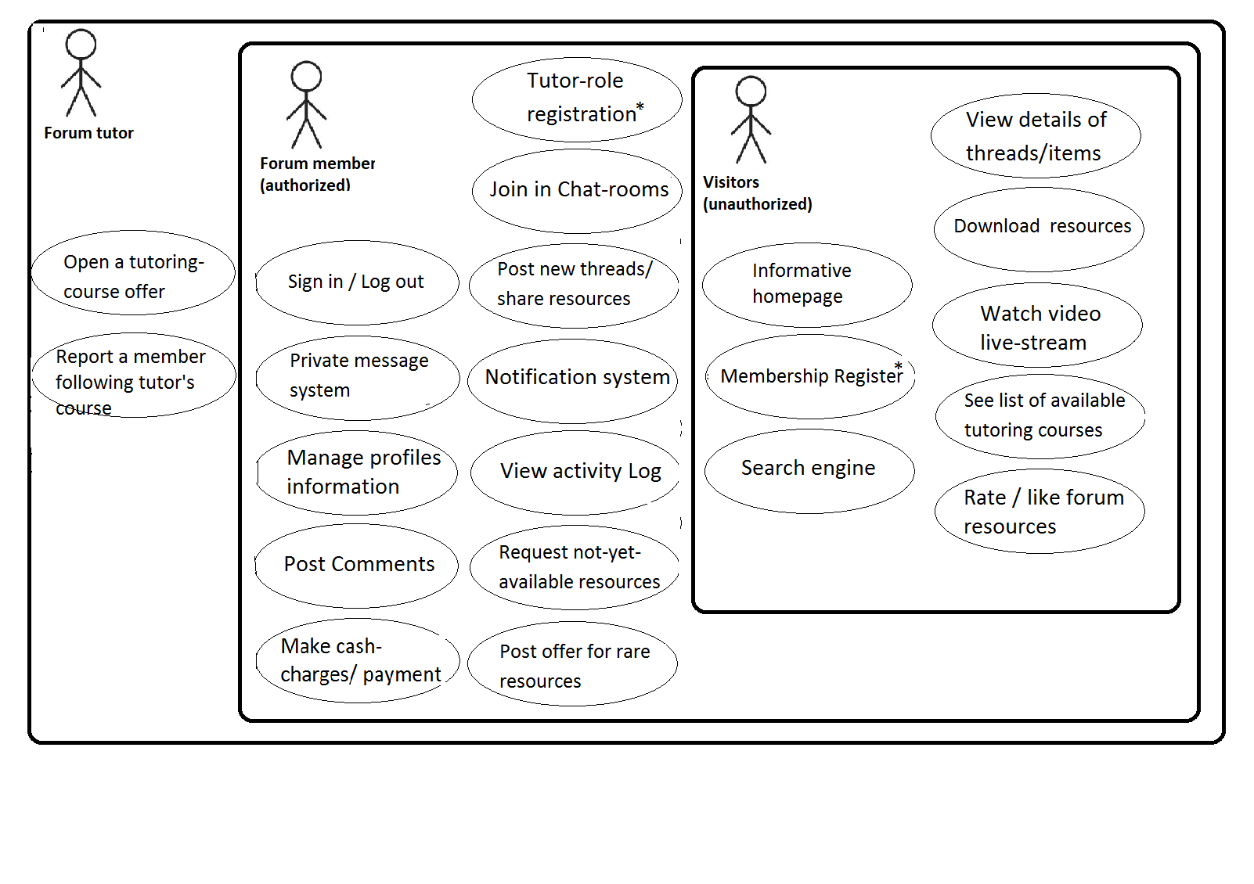

Figure 36 Use-case Hierarchy theme 1

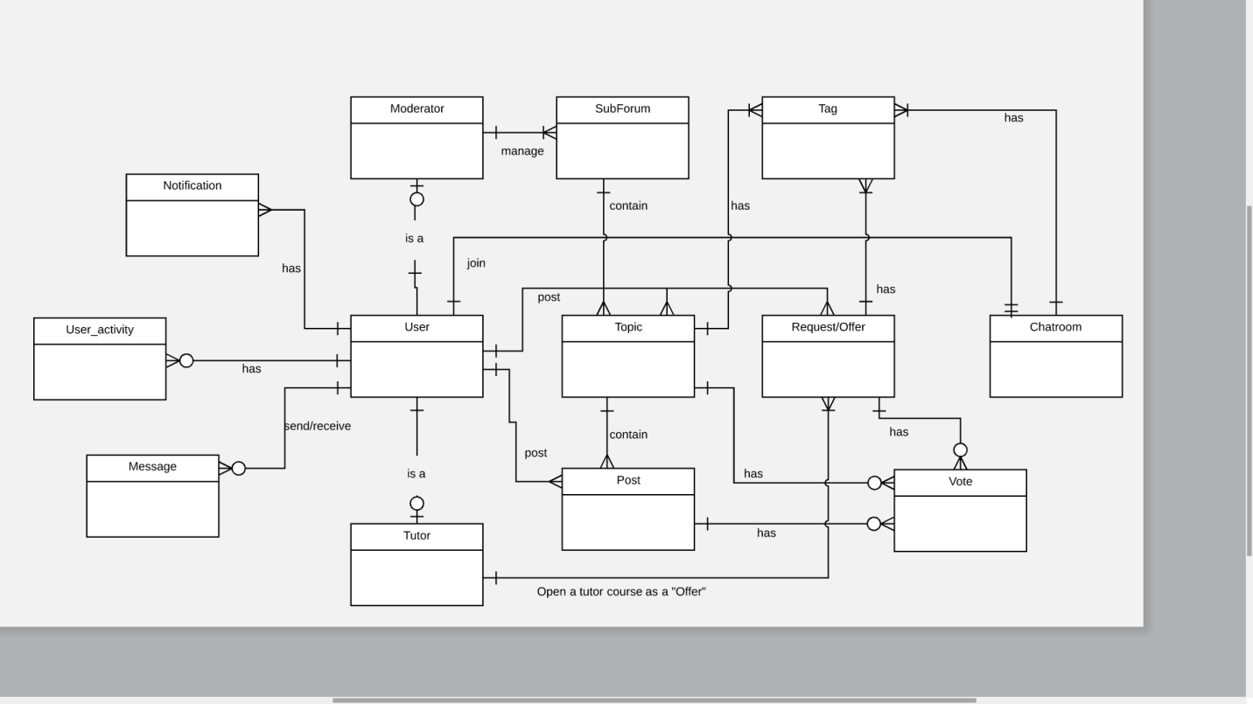

Figure 37 system entity diagram

# Chapter IV Methodology

## 4.1 Project overall structure

Let me bring out the overall layout of the project again for easier understanding of the intended scenario.



Main components and their features:



Others components to support the main ones:

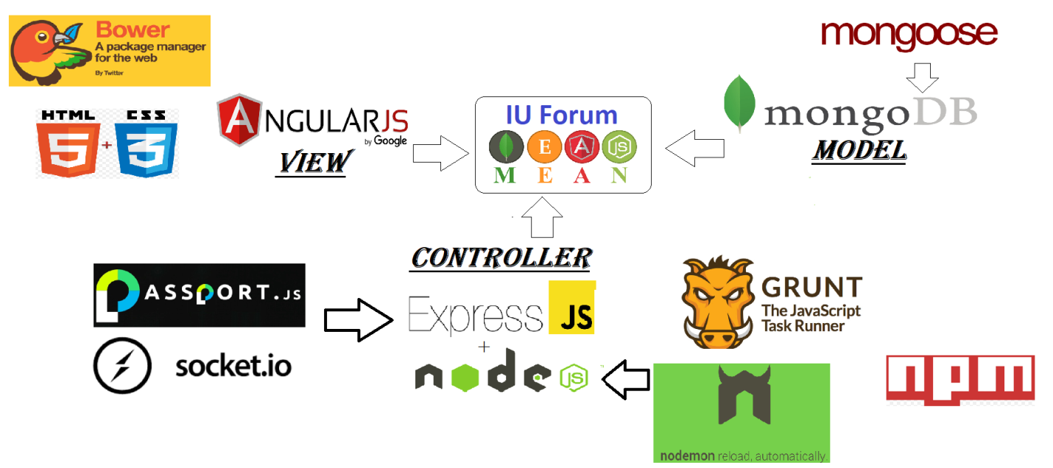

## 4.2 Diagram, layer

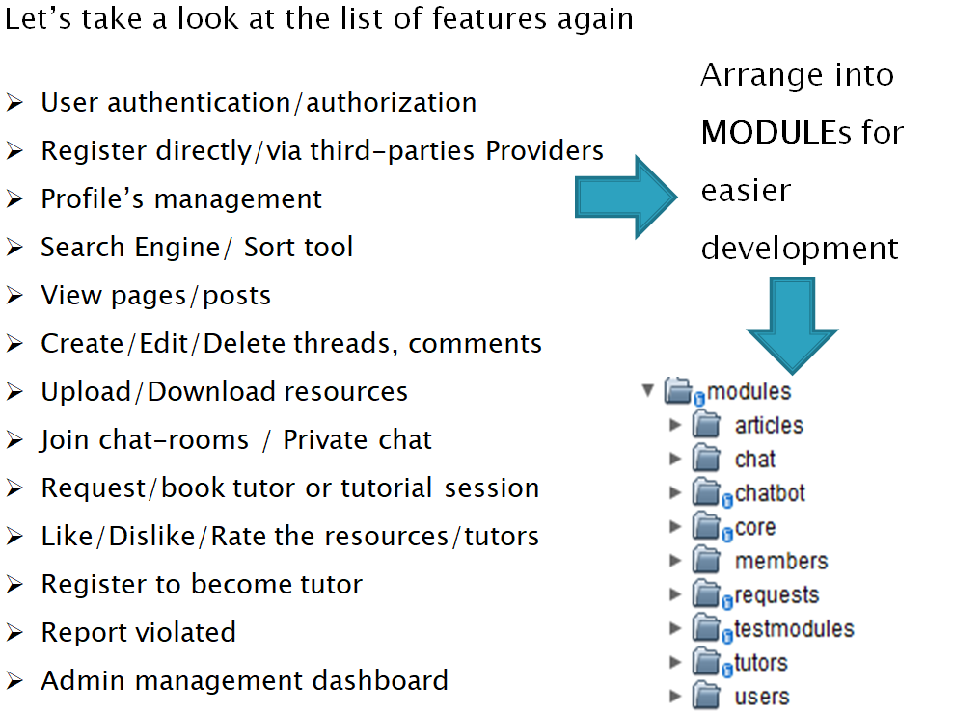

-For a closer look:

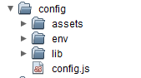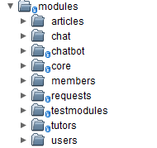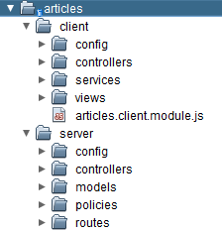

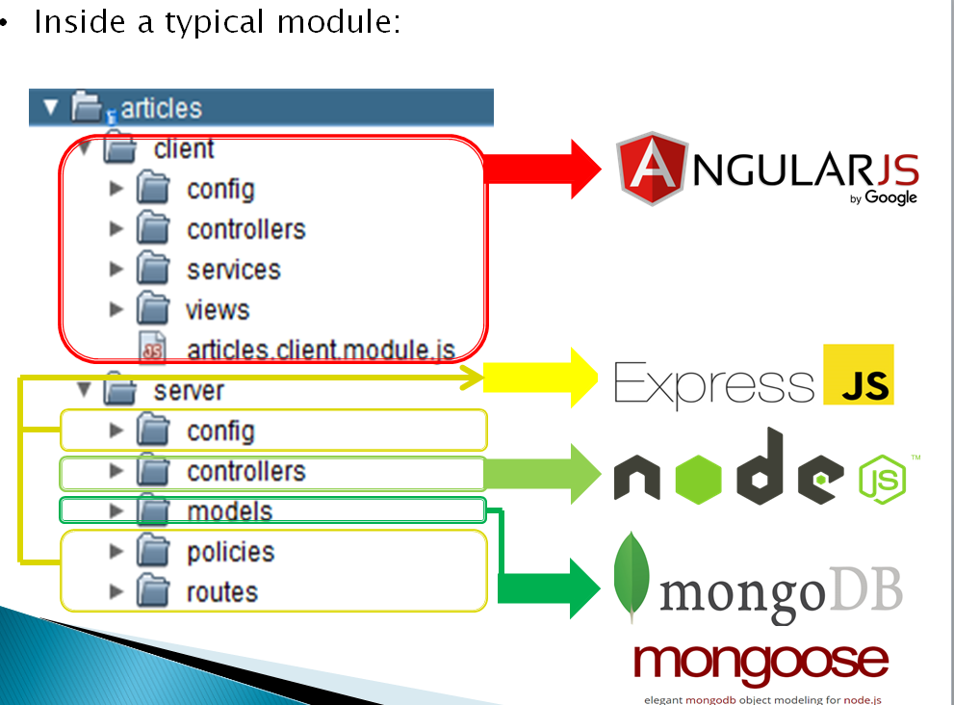

## 4.3 MEAN components

### 4.3.1 The Server-side _ CONTROLER & MODEL

### 

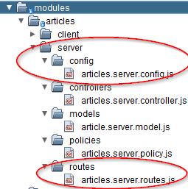

-Node.js ‘exports’ functions from the server-side:

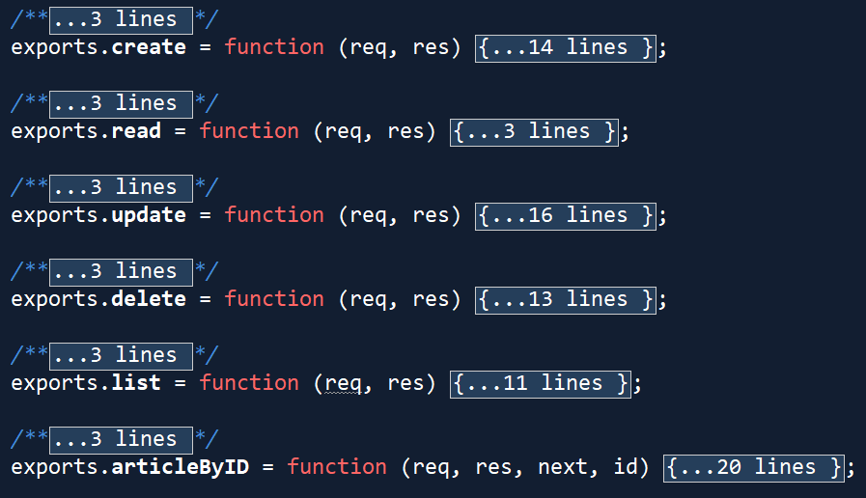

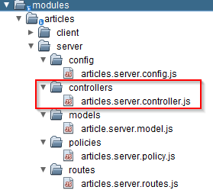

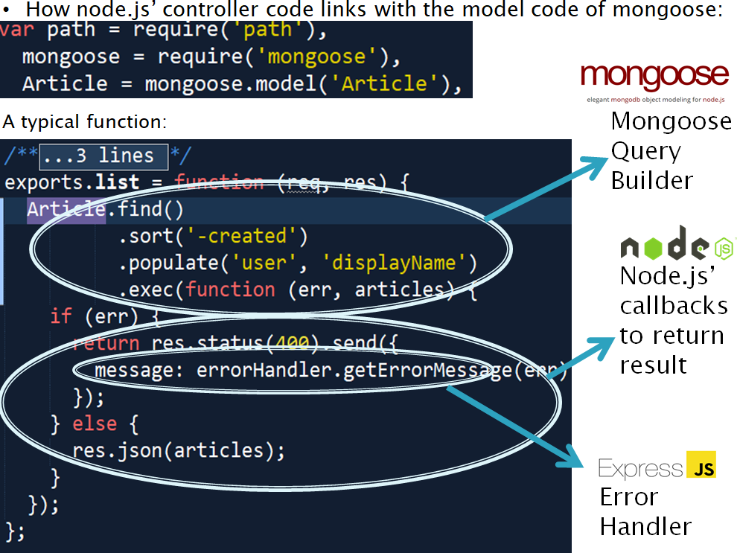

Express Js routing system is used in my project as followed

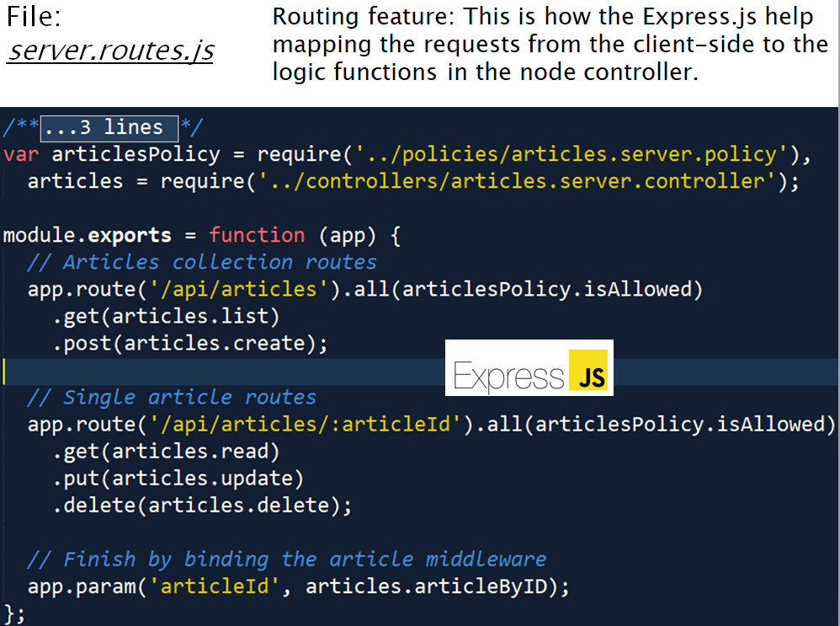

### 4.3.2 Mongo database for MODEL in server

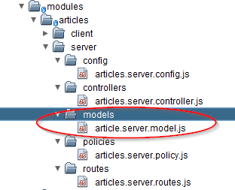

Setting up connections in the configuration file, very simple lines of codes as you can see: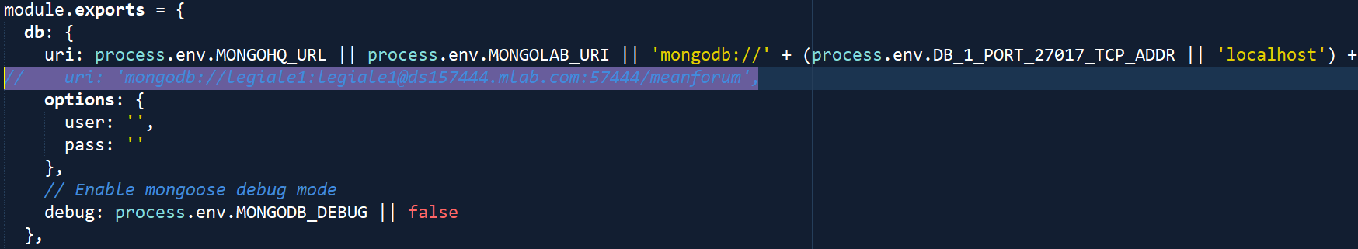

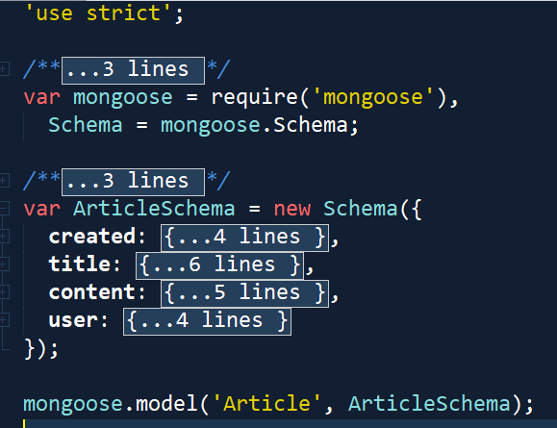

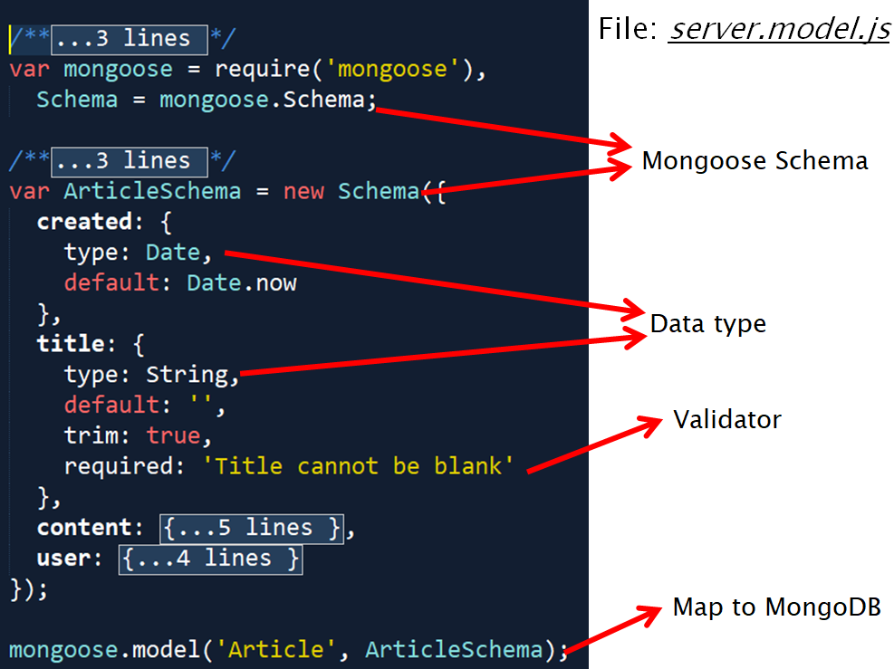

### 4.3.3 Angular.js for VIEW

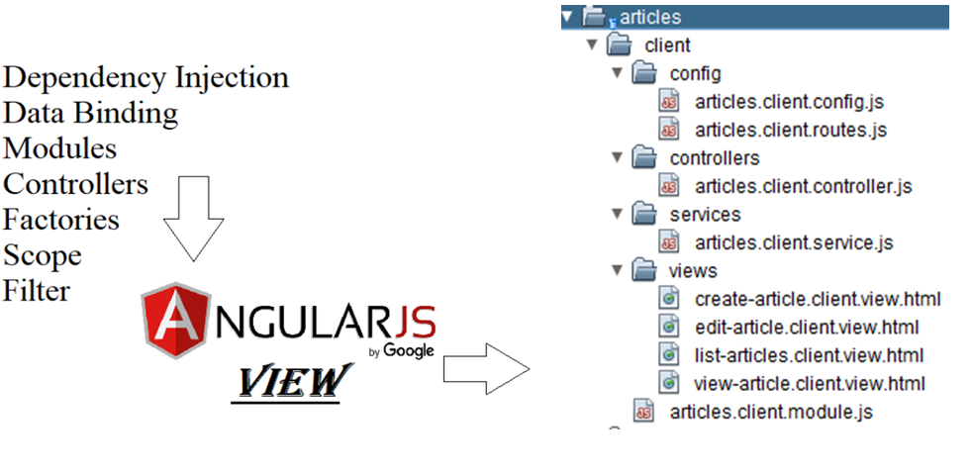

First thing first, register an angular module:

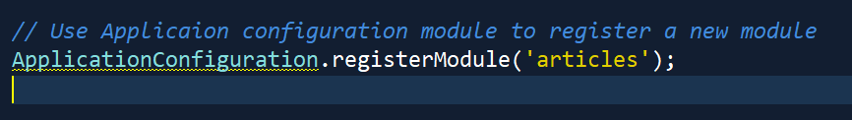

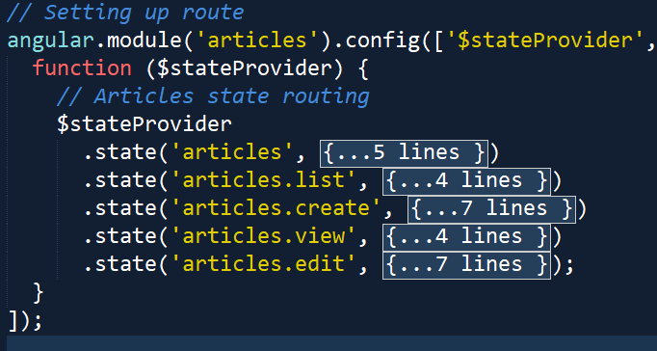

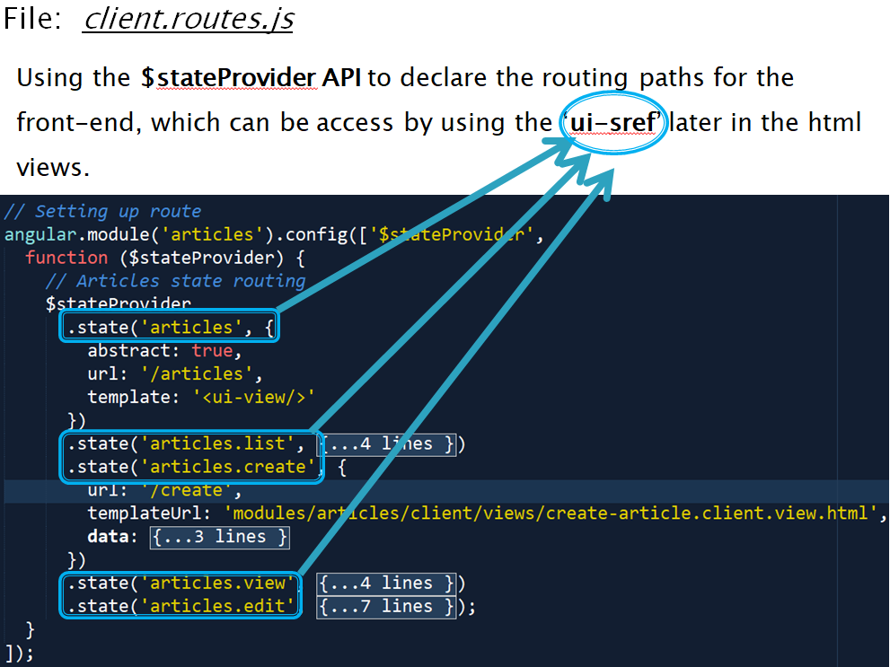

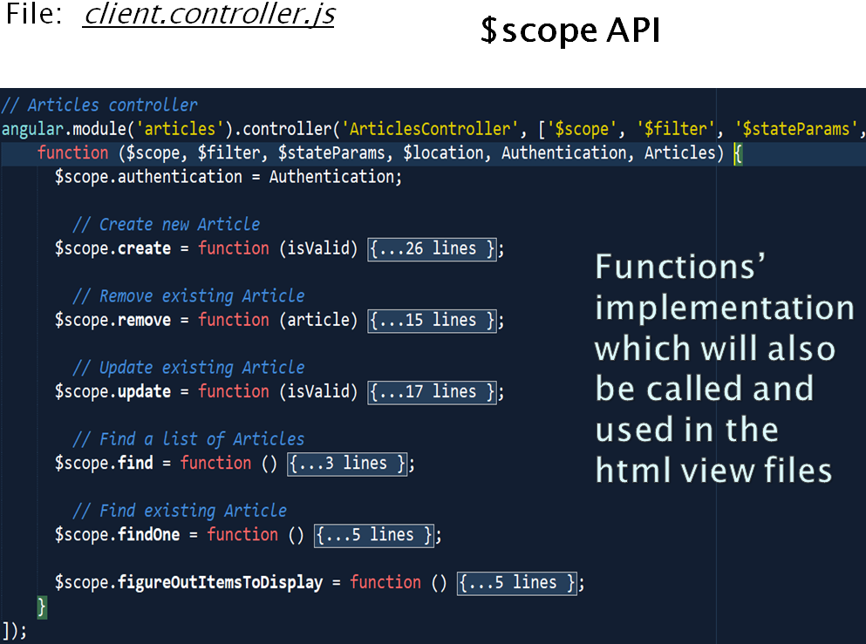

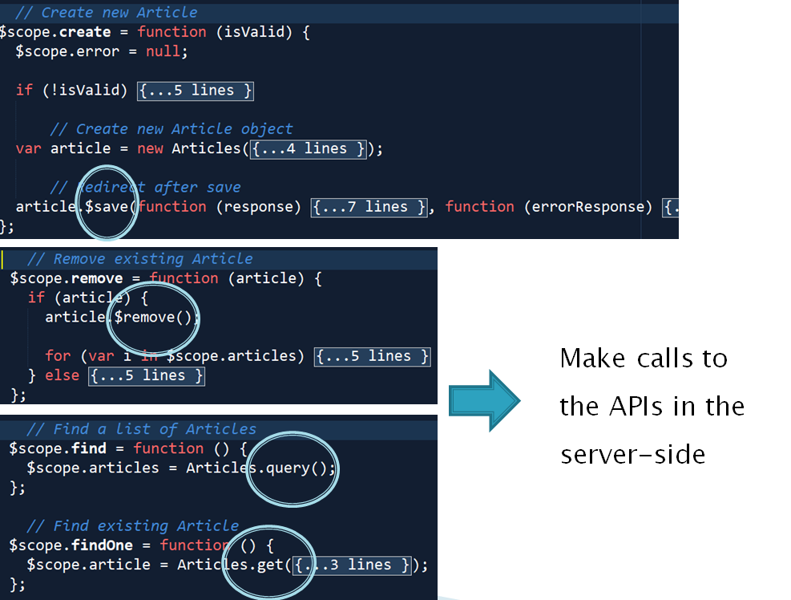

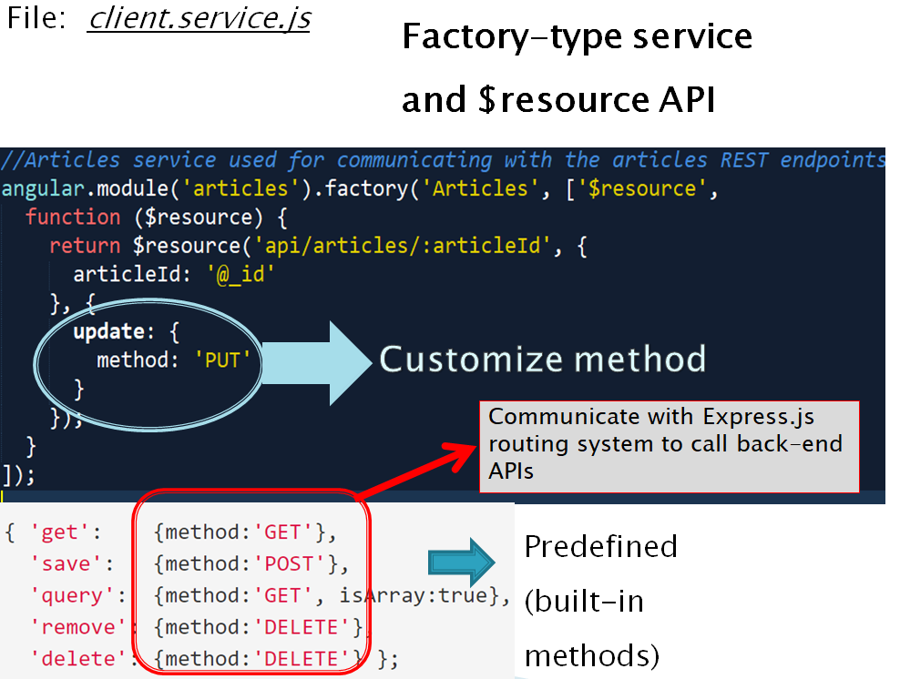

### 

# Chapter V Implementation & Result

Nod.js’ Server running using GRUNT and NODEMON to support

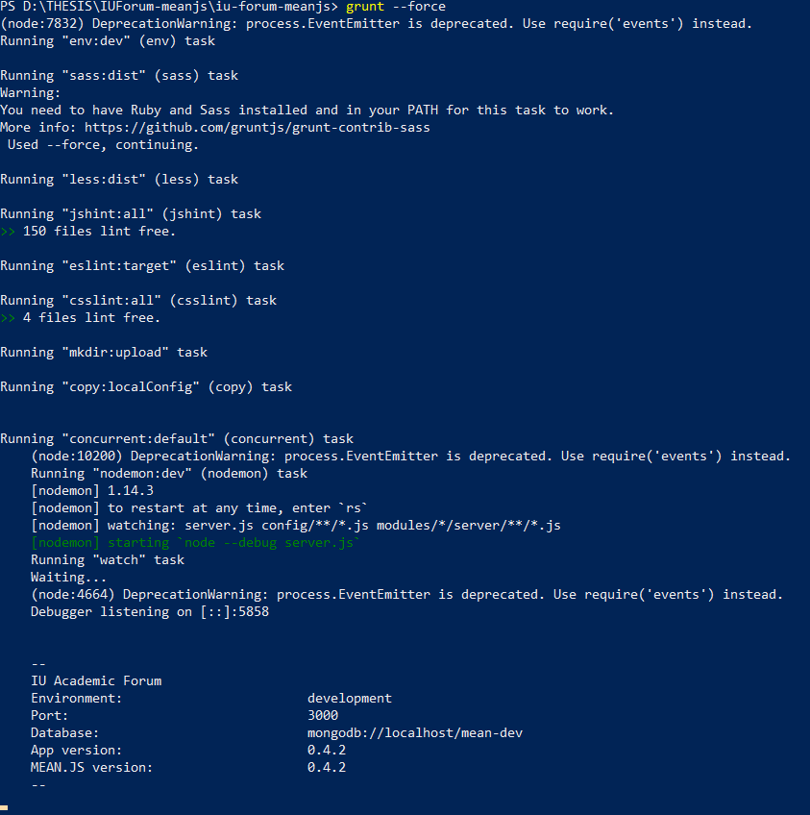

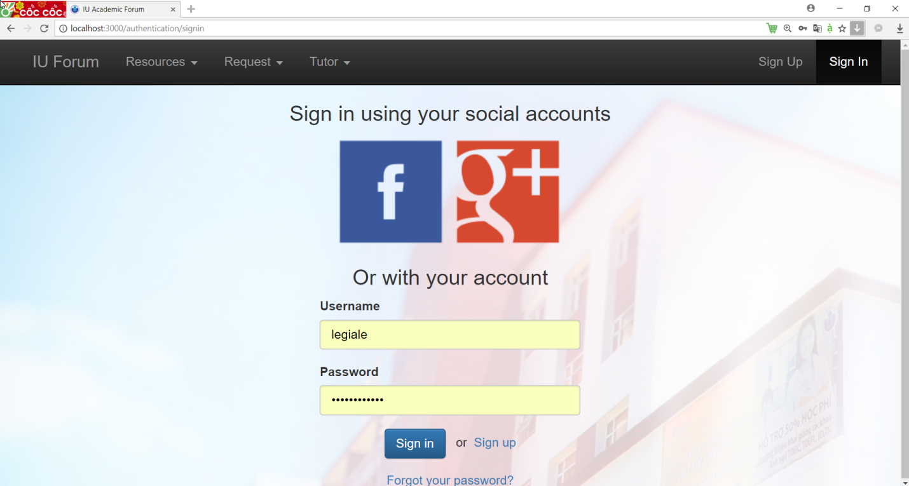

Signin / Sign-up feature

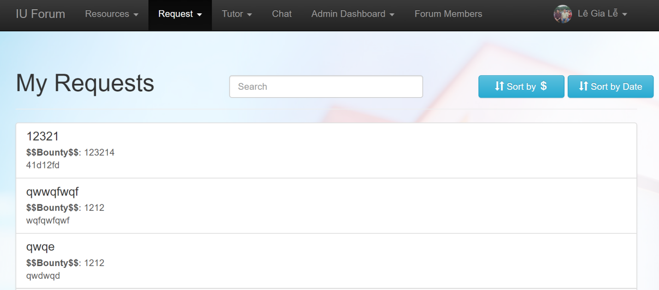

Request for resouces

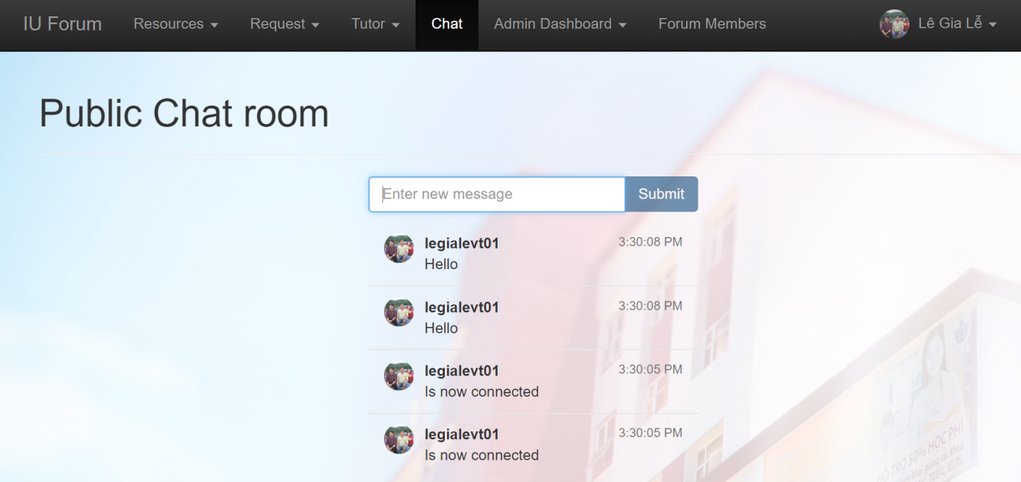

Public Chat room using Socket.io

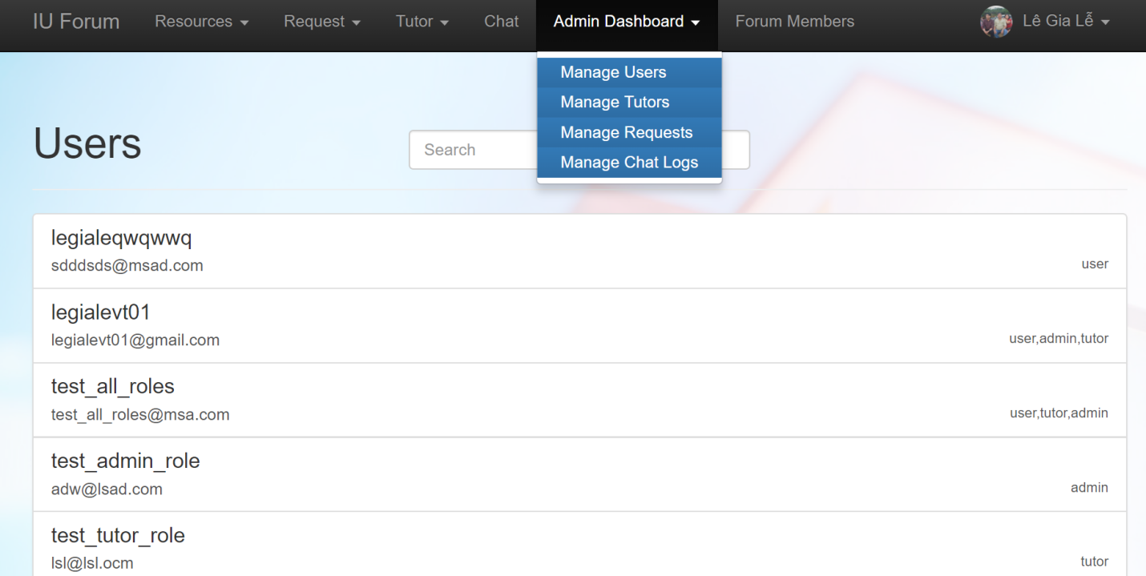

Admin dashboard ( CRUD )

# 

User profile settings

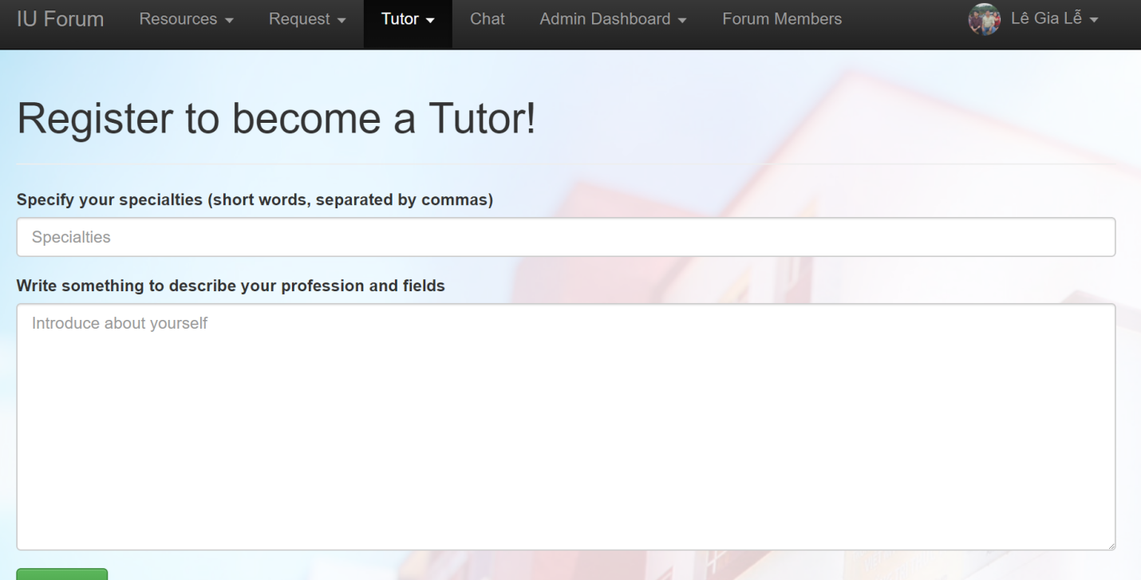

# Chapter VI Conclusion

## 6.1 Gains

In this thesis project, i walked through the key pieces of a MEAN application, step-by-step.

On the server side, i learned that the path started with Express routes, which in turn invoke Express controller functions, which in turn merge JSON data and return it to the client.

On the client side, AngularJS routes pick up and inject HTML templates into the main page.

As well as many other useful tools that come along with the MEAN components

After thesis, I have learnt a lot of new things, I learnt a lot of technologies such as AngularJS, Angular 2, MongoDB, Spring MVC, Node.js, Express Framework. I can work with lots of frameworks and I have ability to learn new technology. I also had a lot of experience in building single page application. I will improve myself in the future for working in professional environment

## 

## MEAN stack, the good parts

The primary reason for preferring MEAN stack over others is because of the use of a common language for both client-side and server-side. Since, all these technologies are written in JS the web development processes becomes neat. And also JS doesn’t require a software of its own, it all needs its own web browser for executing a web page or an application. Node.js is a platform that brought JavaScript implementation on the server-side. With Angular.js, using JavaScript on the front-end, it becomes easier to reuse code from back-end to front-end.

## 6.3 Overall conclusion

MEAN stack is good investment for building fast, strong and scalable applications. It is catching up with the other tech stacks in the market and has already made it’s mark in the development community.

MEAN stack offers a modern and an effective approach to web development. It also makes use of the power of modern SPAs (single-page applications), which does not require entirely refreshing a web page for every server request like most traditional web applications do. All the technologies present in the MEAN stack are free and open-source in nature. Hence, users are benefitted by any developments or version upgrades in the way of contributions done by a vast community of developers.

# Reference

[1] Michael S. Mikowski and Josh C. Powell, Foreword by Gregory D. Benson,

Single Page Web Applications JavaScript end-to-end, 2013

[2] Philip Klauzinski, John Moore , Mastering JavaScript Single Page

Application Development, 2016

[3] Thomas A. Powell, Ajax: The Complete Reference 1st Edition, 2008

[4] Architecture Overview, Angular.io

https://angular.io/guide/architecture

[5] What Is AngularJS?, Google

Accessed: December 25, 2017

https://docs.angularjs.org/guide/introduction

[6] By Mehdi, Why Angular? Why Angular 2?,

https://blogs.msmvps.com/deborahk/why-angular-why-angular-2/

[7] RESTful Web Services Tutorial

https://www.tutorialspoint.com/restful

[8] Node.js, Node.js Foundation

https://nodejs.org

[9] Express. Fast, unopinionated, minimalist web framework for Node.js; StrongLoop, IBM, and other expressjs.com contributors

https://expressjs.com/

[10] MongoDB and MySQL Compared, MongoDB, Inc

https://www.MongoDB.com/compare/MongoDB-mysql

[11] MongoDB Architecture, MongoDB, Inc.Mongo

https://www.MongoDB.com/MongoDB-architecture

[12] MEAN stands for, Mean.io contributors

http://meanjs.org/

[13] 05 May 2008, Understanding Model-View-Controller, Written by Jeff Atwood

Accessed: January 17, 2018

https://blog.codinghorror.com/understanding-model-view-controller/

[14] Valentin Bojinov, RESTful Web API Design with Node.js - Second Edition, 2016

[15] Introduction to Socket.io  
https://socket.io/

[16]: Joris Hermans, Web Development with Node.js, MongoDB and Express, 2017

[17]: Amos Q. Haviv & Adrian Mejia & Robert Onodi, Web Application Development with MEAN, 2016.

[18]: Introduction to Mongooe.js for MongoDB  
https://medium.freecodecamp.org/introduction-to-mongoose-for-mongodb-d2a7aa593c57

[19]: Why would we use Node.js Event-loop  
https://medium.com/the-node-js-collection/why-the-hell-would-you-use-node-js-4b053b94ab8e

[20]:Mongoose.js Introduction  
http://mongoosejs.com/

[21]:Introduction to passport.js, An Authentication and Authorization strategy  
http://www.passportjs.org

[22]: Types of NoSQL  
https://www.upwork.com/hiring/data/sql-vs-nosql-databases-whats-the-difference/

[23]: What is Angulsrjs and how does it work?  
http://mindbowser.com/what-is-angularjs-and-how-it-works/

[24]:Using Bower  
http://durandaljs.com/documentation/Bower.html

=======================================================